Washington

Mercer Island, Washington 3

Mercer Island, Washington
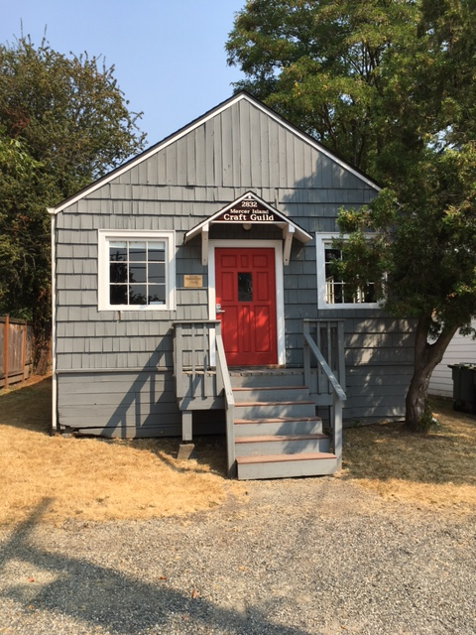
One of our docents, Carolyn Yost, sent these photos of a Shotgun House structure that she discovered. Here’s her report:
“It’s just down the block from my cousin's house on Mercer Island, which used to be a vacation location but now is really ritzy. Sound familiar? It is filled with table saws and things like that.”

Carolyn inquired about the history of the building and received this response from Jane Meyer Brahm of the Mercer Island Historical Society:
“The Mercer Island Craft Guild was never built as a house. . .Apparently in the late 1930s, some neighbors on the north end wanted to pool their resources and share their power tools for woodworking and boat building. According to the records the group kept, 10 men got together on April 4, 1940, and formed a co-op. They bought an undersized lot for $50 at a tax sale, and they set about building a 1,000 sq. foot wood shop. They salvaged most of the wood from the construction of the I-90 floating bridge, and gathered tools. There is no plumbing, and the place is still heated by a 55-gallon chip-burning barrel.
Membership dues pay the bills, and members receive a key to the club. Membership ranges from 30 to about 70. The Craft Guild is strictly for hobbyists and is not used for commercial purposes.”

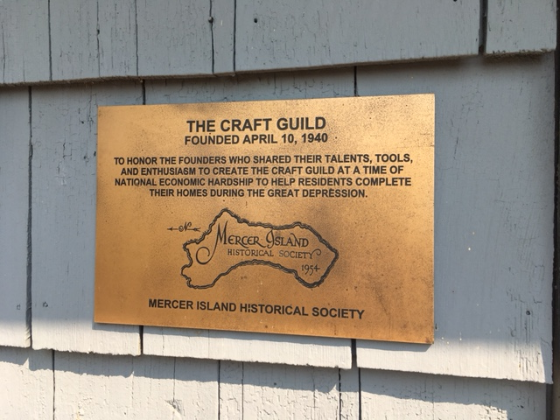

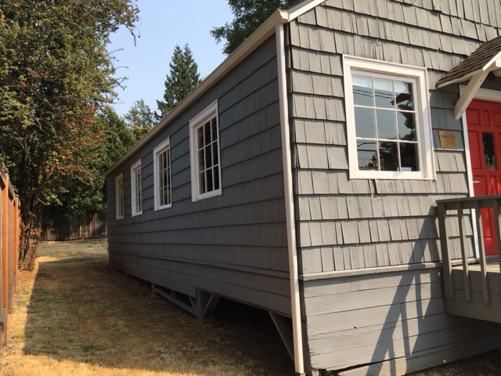

The hall is located in the former East Seattle neighborhood at 2832 61st Ave SE, Mercer Island, WA.

Many thanks to Carolyn Yost, Jane Meyer Brahm and the Mercer Island Historical Society!
http://mercerislandhistory.org/

Later Carolyn emailed to say:
“There is another shotgun house in Tacoma in a big park by the water. It is housing for lumber jacks and is on a train car.”

