Washington D. C.

Washington, D.C. 3

Washington, D.C.
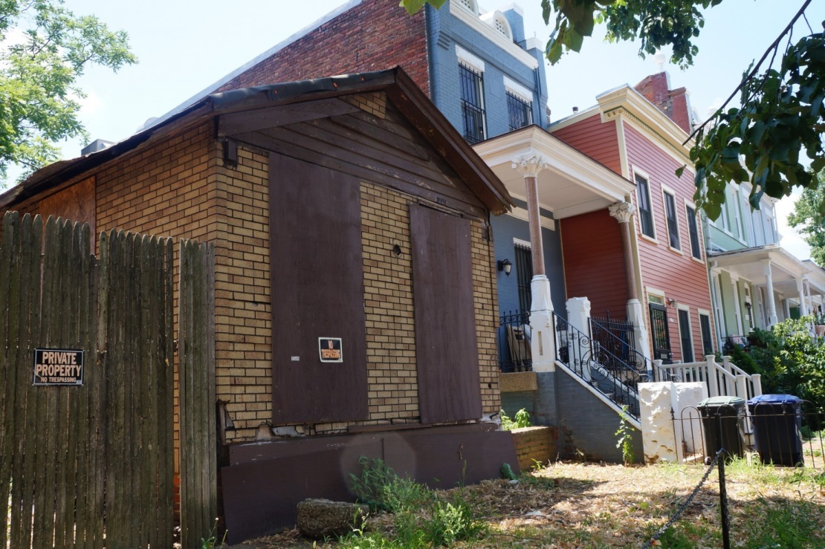
The shotgun-style house at 1229 E St. SE is seen in the Capitol Hill Historic District. (Ileana Najarro/The Washington Post)
Pre-Civil War shotgun house in the hands of D.C. preservation board
To some people, the one-story house at 1229 E. St. SE on Capitol Hill is a classic example of the form. To others, the boarded-up, rectangular shack with the cracked wooden frame is an eyesore worthy of replacement.
This disagreement has led to a tug of war between an owner ready to demolish the place and a preservation group demanding that it be restored.
Bordered by two-story rowhouses, the brown shotgun house on E Street seems out of place. The wooden walls look as if chunks have been bitten out of them, and the brick foundation is exposed in front for the world to see. The house is just 14 feet wide and three rooms deep. It has a single long window and a door in front. There is no longer a porch for the dilapidated roof to cover.
Though the origins are unclear, the story goes that the owner of a local store built the house some time before 1853. A German immigrant peddler bought it and lived there with his family for 40 years, according to the Capitol Hill Restoration Society, and the house may have been owned by a bricklayer who occupied it until the 1940s.
The current owner, Larry Quillian, bought the property in 1985. Quillian, thought he could tear down the derelict house and build a bigger one. He quickly discovered, however, that in the Capitol Hill Historic District, it wouldn’t be that easy.
Society members oppose demolition because of the house’s historical and structural integrity. They contend that the house contributes to understanding of working-class life in the Capitol Hill neighborhood before the Civil War.
Richard Longstreth, director of the historic preservation program at George Washington University, said the builder of probably came from the Deep South or the Ohio River Valley, where he would have become familiar with the design.
By Ileana Najarro July 15, 2014, The Washington Post
https://www.washingtonpost.com/local/dc-politics/pre-civil-war-shotgun-house-in-the-hands-of-dc-preservation-board/2014/07/15/72164f06-fd85-11e3-8176-f2c941cf35f1_story.html

