Indiana

Bloomington, Indiana 3
New Albany, Indiana 4

Bloomington, Indiana
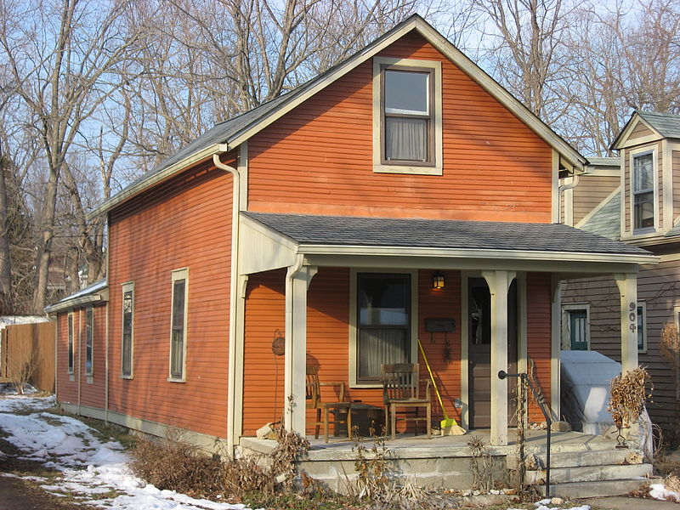
A single shotgun house in Bloomington, Indiana
https://upload.wikimedia.org/wikipedia/commons/thumb/a/a4/Seventh_Street_West_904%2C_Bloomington_West_Side_HD.jpg/800px-Seventh_Street_West_904%2C_Bloomington_West_Side_HD.jpg
https://en.wikipedia.org/wiki/Shotgun_house

New Albany, Indiana
House types and architectural styles prominent in New Albany, Indiana: Shotgun (1860-1920)
Characterized by:
•One room wide and one or two rooms deep, modest size.
•Lengthwise roof ridge.
•May have added two-story section on rear. Double shotgun is two rooms wide with two windows on house front.
•May exhibit architectural details from any style.
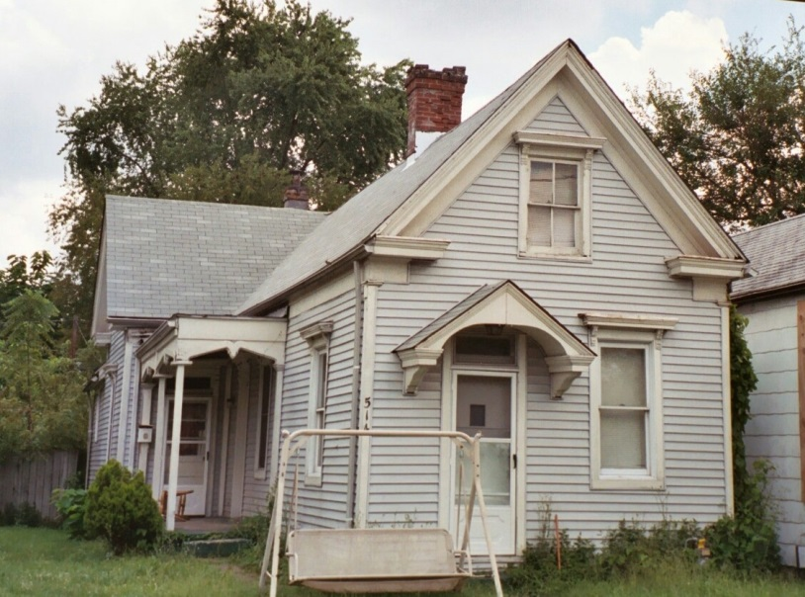

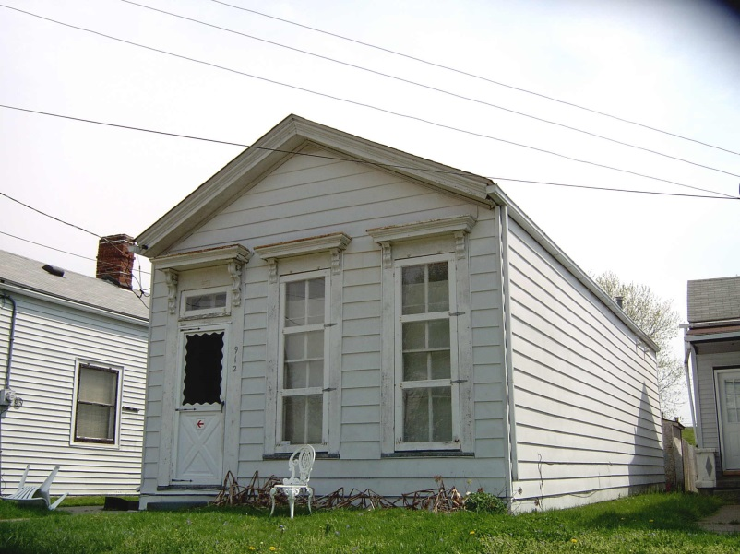
This is a shotgun cottage.
Note: Combining "cottage" with any term used to describe a house type or style generally indicates that the building is a smaller version of the type or style. "Cottage" itself is not a house style or a house type.

http://www.historicnewalbany.com/default.asp?q_printview=1&q_areaprimaryid=9

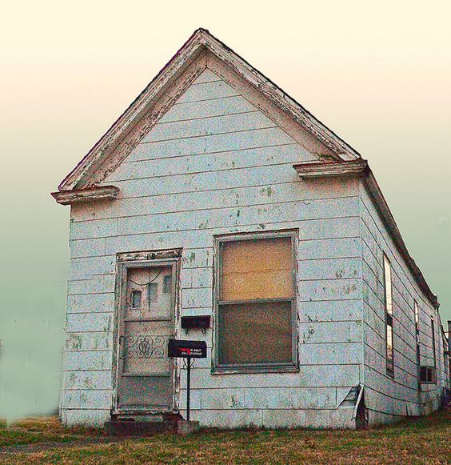
https://www.pinterest.com/pin/474848354430653745/?lp=true

Shotgun houses make up a substantial portion of New Albany's stock of historic homes
www.newalbanypreservation.com/uploads/File/NAguides_shotguns.pdf
