Louisiana

Donaldsville, Louisiana 3
Leesville, Louisiana, Museum of West Louisiana 4
New Orleans, Louisiana 5
New Orleans, Birthplace of Art & Charles Neville, Neville Brothers Quintet 18
Unknown Location, Louisiana 19

Bonus Section (after the pink divider sheet)

Shotgun Homes for Sale in New Orleans, Mapped

Donaldsville, Louisiana
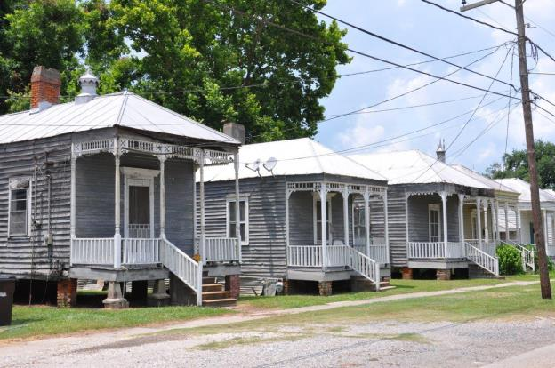
Historic Shotgun Houses in Donaldsonville
http://gettinglostinlouisiana.blogspot.com/2013_06_01_archive.html

Leesville, Louisiana, Museum of West Louisiana

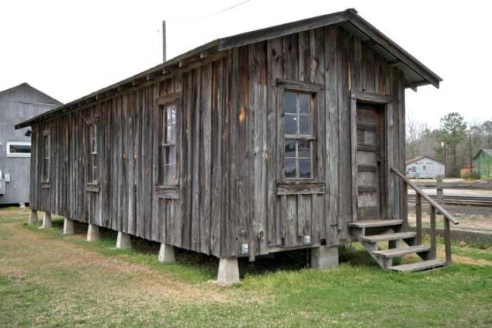Shotgun House: one of the architectural styles which could be found in the area in the 1800 - early 1900s period.

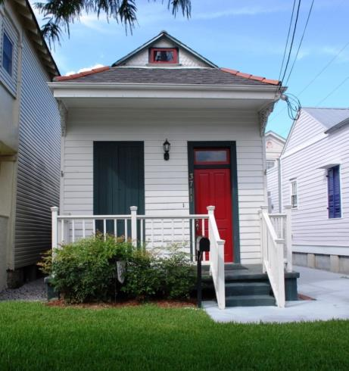
New Orleans, Louisiana

Iberville block in Mid-City leaves one stroller hungry for more; www.nola.com

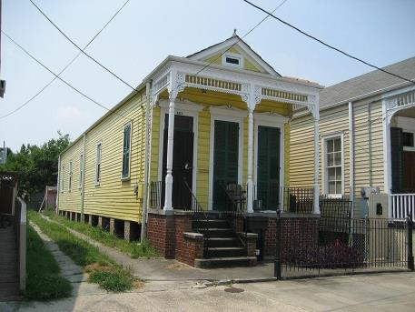

Shotgun Houses, Camelback Homes and Other Creative Names for Architectural Styles

Photos used by permission: Wikimedia Commons. Thanks to Infrogmation and Susan Murray, photographers.
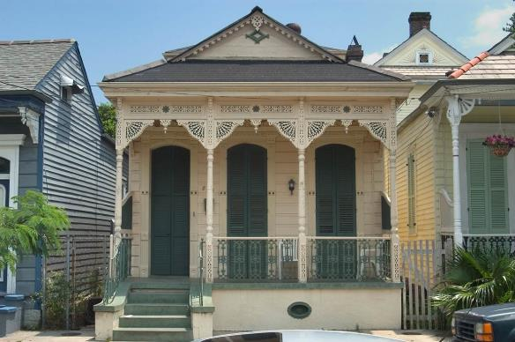

Louisiana Shotgun House

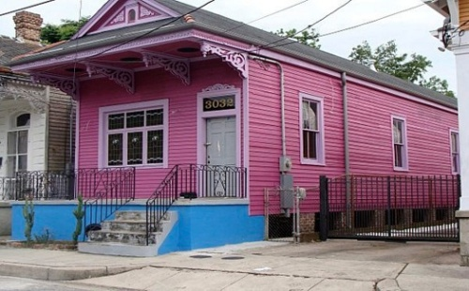

Shotgun House Renovation Contractor
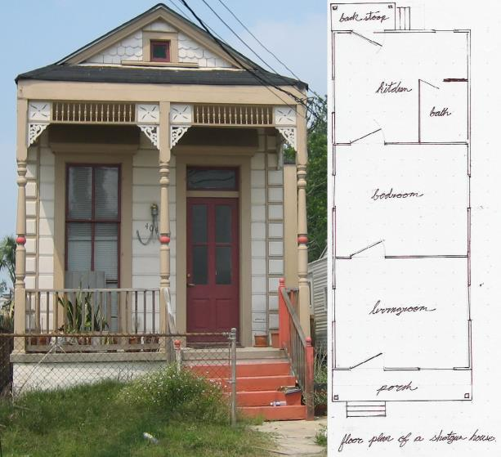

http://www.tinyhousedesign.com/wp-content/uploads/2008/10/shotgun-house-photo.jpg
Figure 3: The most ornate Victorian style shotguns are usually found in New Orleans, where sophistication and class distinction are important aspects of the local culture. This home features a vent on the front gable, a full front porch with turned wood posts, gingerbread brackets and other ornamentation. (Photo credit: Gregory Smith www.tinyhousedesigns.com)
Referenced on pg. 23 of Old House, New Future: The Quiet Revival Of The Shotgun House, By Belinda A. Tate, A Thesis Submitted to the Graduate Faculty of Wake Forest University, In Partial Fulfillment of the Requirements For the Degree of Master Of Arts In Liberal Studies, May 2010, Winston-Salem, North Carolina.
Copyright by Belinda Tate

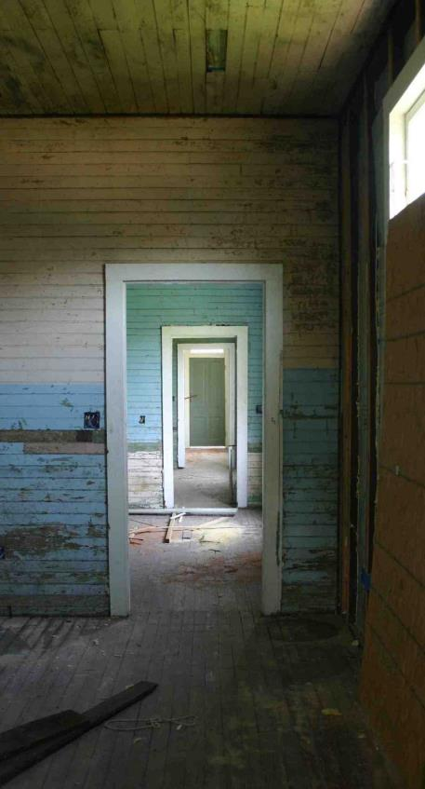

Century-old shotgun house under renovatio in the Lower 9th Ward's historic Holy Cross Neighborhood, New Orleans, LA. The nonprofit Preservation Resource Center buys up old and neglected homes, renovates them and sells them to entry-level buyers.

kathyprice.typepad.com

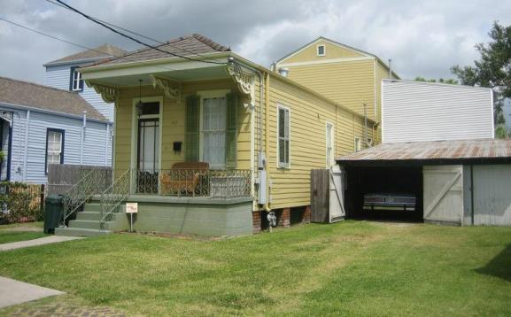
Shotgun Houses, Camelback Homes and Other Creative Names for Architectural Styles
Photos by permission: Wikimedia Commons. Infrogmation and Susan Murray, photographers.
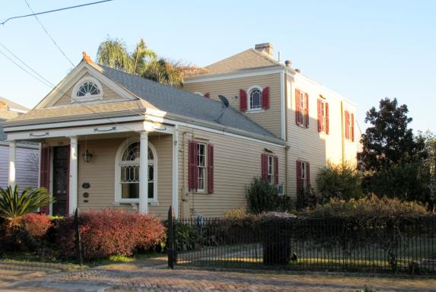
“Camelback” shotgun houses, for instance, have a partial second floor – or the humpback – over the rear of the house. The reason for this peculiar design, as it often does, had to do with taxation rules. Because the second story was only partial, the city still taxed such houses as single-story. http://sandstoneandamber.com/2012/02/25/post-mardi-gras-respite-in-algiers-point/
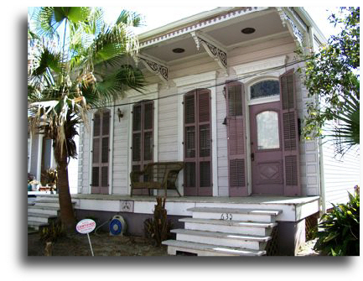
Settled 1719, Algiers Point is New Orleans’ second oldest neighborhood and listed on the National Register of Historic Places.
630 Pacific Ave.
Built in 1892. This renovation of New Orleans’ most famous “shotgun” house was seen on PBS Television’s “This Old House” in 1991. The floor plan of the shotgun house is arranged with all the rooms in a straight line from front to back allowing a bullet shot from the front door to pass out the rear door without hitting anything. This home was originally a double, or two family, shotgun, and has been converted into a single.

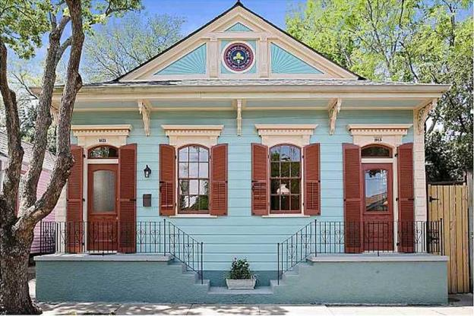
http://circaoldhouses.com/property/historic-faubourg-street-shotgun-house/
More information on New Orleans Shotgun Houses:
https://archidius.wordpress.com/2011/08/12/the-new-orleans-shotgun-house/
http://www.nola.com/homegarden/index.ssf/2014/02/shotgun_geography_new_orleans.html
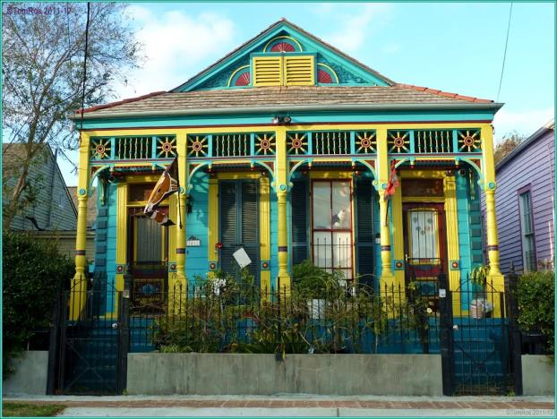
Great Paint Job, obviously! Many New Orleans houses are decorated quite spectacularly. It is almost a competition!
I just love the fact, that they have a Black& White cat to go with all the colours.
This photo was in NPC July 2012 contest Small Houses.
http://www.panoramio.com/photo/67811677
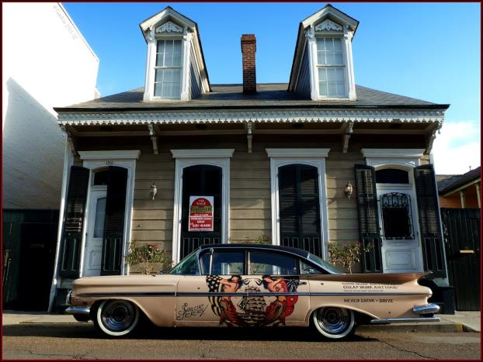
Big car or small house?... obviously no garage!
Good work ain't cheap; cheap work ain't good reads the inscription on this car. Parked on Charters, one of the main New Orleans streets. Probably Chevrolet Impala between 1958-59.(longest Chevy ever made!) House is probably 100 years older (around 1800). Sailor Jerry in NOLA. http://www.panoramio.com/photo/67811692
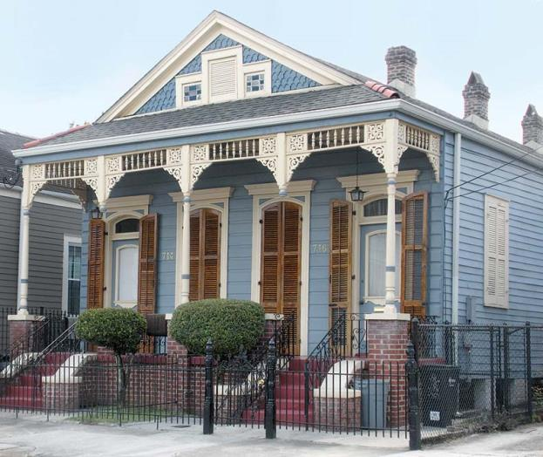
Painted in pastel blue, this classic Shotgun house retains its Victorian embellishments.

Architecture & Culture in New Orleans’ Faubourg Marigny
Filled with old-timers and artists, The Marigny is a bohemian neighborhood against a backdrop of pastel Shotgun houses and colorful Creole cottages.

http://www.oldhouseonline.com/architecture-culture-new-orleans-faubourg-marigny/

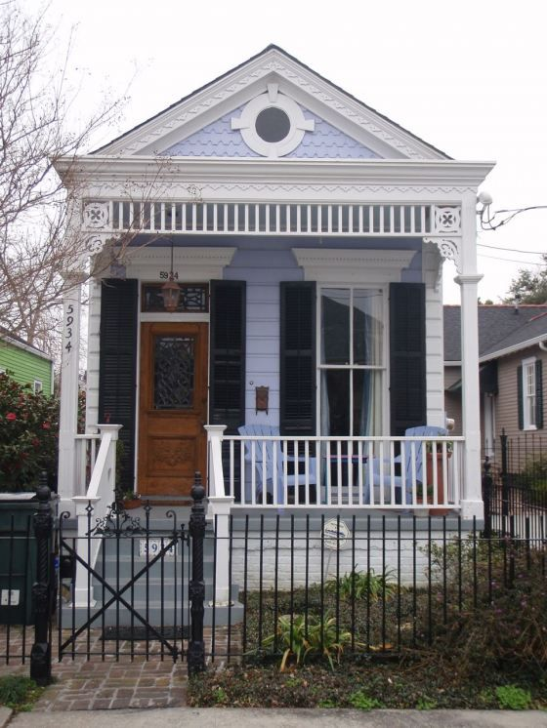
Shotgun house with elaborate trim work, lavender siding, grey porch floor
https://www.pinterest.com/pin/284008320228240497/

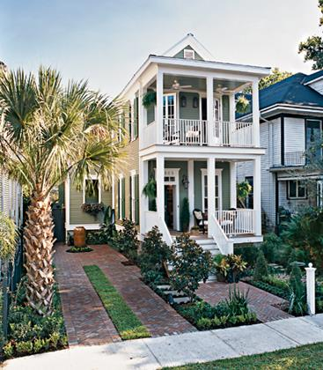
Built inside a South Carolina factory and shipped to its home in one of New Orleans’ historical neighborhoods, this shotgun cottage is the most popular building style in the Big Easy. Most shotgun houses are one room wide, and three to five rooms deep.
http://www.myhomeideas.com/idea-houses/grand-tours-new-orleans-shotgun-cottage

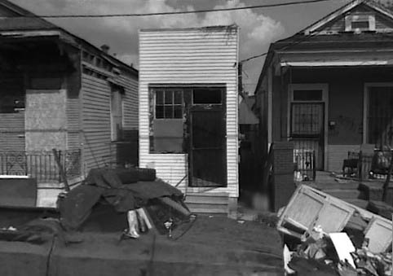
The Smallest of the Smallest in Shotgun Houses
Tiny Shotgun Dwelling (Office), 1100 Block of Louisa Street, St. Claude Avenue, New Orleans, Louisiana

The Smallest of the Small in Context…
Since a dumpster was blocking our view of this building, we have provided a side elevation of the tiny shotgun type building.

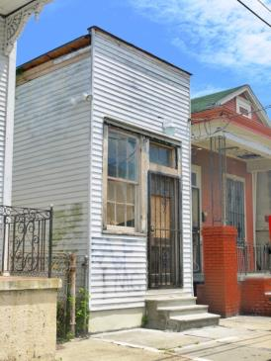
This shotgun is truly among the smallest buildings we’ve seen. Perhaps originally built as an office, the building appears to have been converted to a residence at some sad, but clever point. New Orleans is one of the few cities in America with a strong feeling of urban small town, but with a critical mass appropriate to its architectural, built context. Located north of St. Claude Avenue and the By-water neighborhood, this section of town leaves something to be desired. Primarily, the buildings are dilapidated as are many of its residents; however, there is still a particular beauty to the place, given the ragged bones of the old, primarily wooden, buildings. We hope to see this return to its former glory, as tiny as that glory may have been.

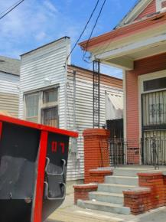

Note the high paraphet at the facade, confirming that the building was probably intended to serve as a small office or shop--most likely an office. The style of the building is as simple as it can be within a certain realm of quality that required wood frame constructure, wood siding, and wood door and window.

New Orleans, Birthplace of Art & Charles Neville, Neville Brothers Quintet
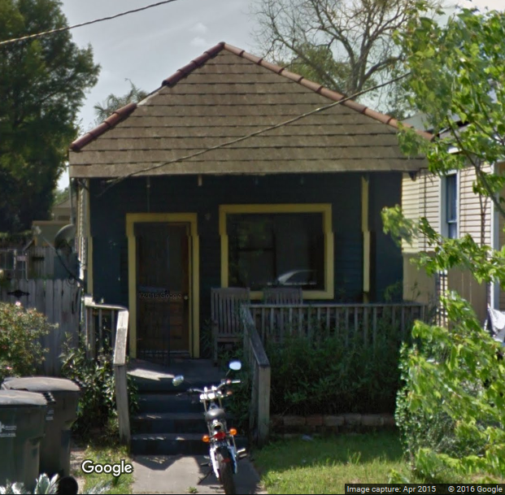
Birthplace of Art and Charles Neville, 1016 Valence Street, New Orleans.

Unknown Location, Louisiana
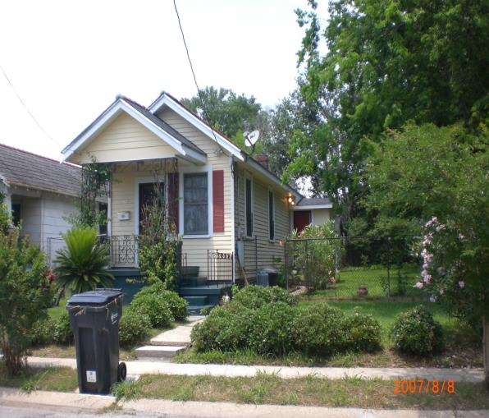

Note the decorative Creole wrought iron railing and porch supports. This Shotgun House like many in Louisiana has Creole Cottage influences.

From: Louisiana Creole Architecture
http://www.frenchcreoles.com/Architecture/creole%20architecture.htm

