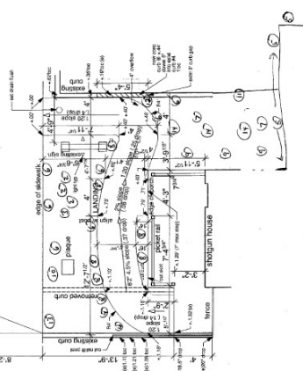
 | Name |  |  |  | Name
 | Common | Botanical |  |  | Common | Botanical
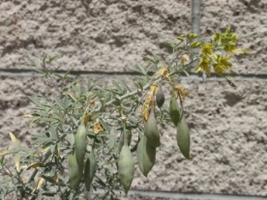 | ①  Bladderpod | Isomeris arborea |  | 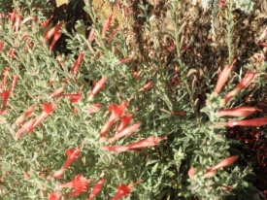 | ②  California Fuchsia | Epilobium canum (Zauschneria)
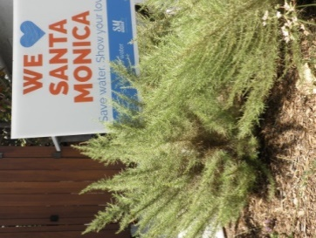 | ③  California Sagebrush | Artemisia californica |  | 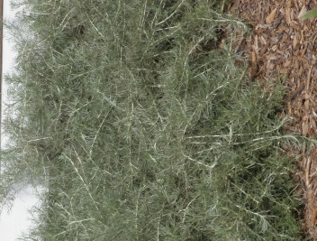 | ④  Canyon Gray Trailing Sagebrush | Artemisia californica ‘Montara’
 |  |  | 2
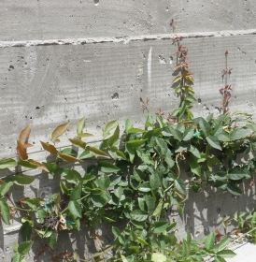 | ⑤  Cat Claw Ivy,  aka Yellow Trumpet Vine | Macfadyena unguis-cati |  | 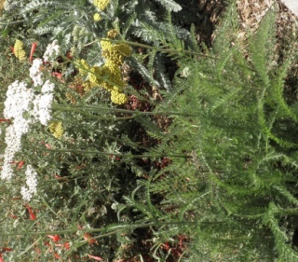 | ⑥  Common Yarrow | Achillea millefolium
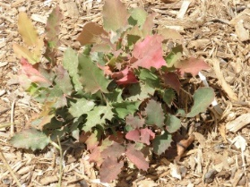 | ⑦  Creeping Mahonia (Barberry) | Mahonia (Berberis) repens |  | 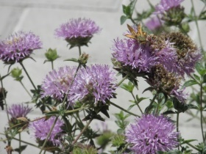 | ⑧  Flax-Leaved Coyote Mint | Monardella linoides
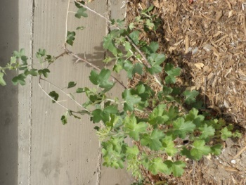 | ⑨  Golden Currant | Ribes aureum gracillimum |  | 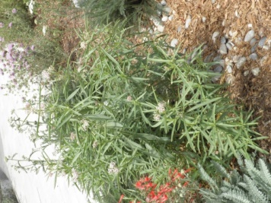 | ⑩  Narrow-Leaved Milkweed | Asclepias fascicularis
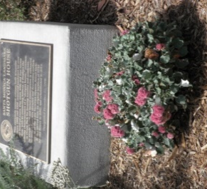 | ⑪  Red-Flowered Buckwheat | Eriogonum grande rubescens |  | 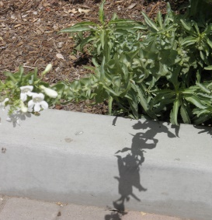 | ⑫  Royal Penstemon | Penstemon spectabilis
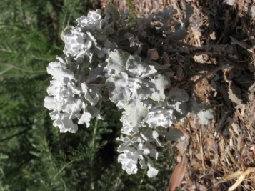 | ⑬  Saffron Buckwheat | Eriogonum crocatum |  | 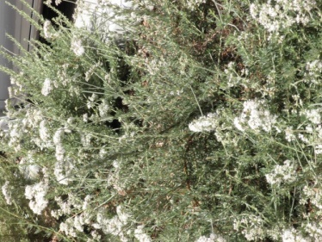 | ⑭  Saint Catherine’s Lace | Eriogonum giganteum
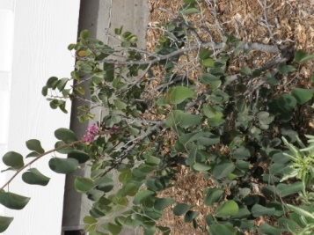 | ⑮  Western Redbud | Cercis occidentalis |  | 2520 2nd Street Santa Monica, CA 90405  (across from the Ocean Park Library just north of Norman Place)

ABOUT THE GARDEN
California native plants fill the garden surrounding the Preservation Resource Center at the Shotgun House. They complement the cottage with their varying colors, textures, forms and aromas. They nourish birds, especially hummingbirds, butterflies and other pollinators. Because they are native, they love our climate and our soil. And they flourish with very little water! Garden design and plant selection by FormLA Landscaping. For more information about the plants, please ask to see the Shotgun House Garden Guide.

