West Virginia

Charleston, West Virginia 3
Pursglove, West Virginia 4

Charleston, West Virginia
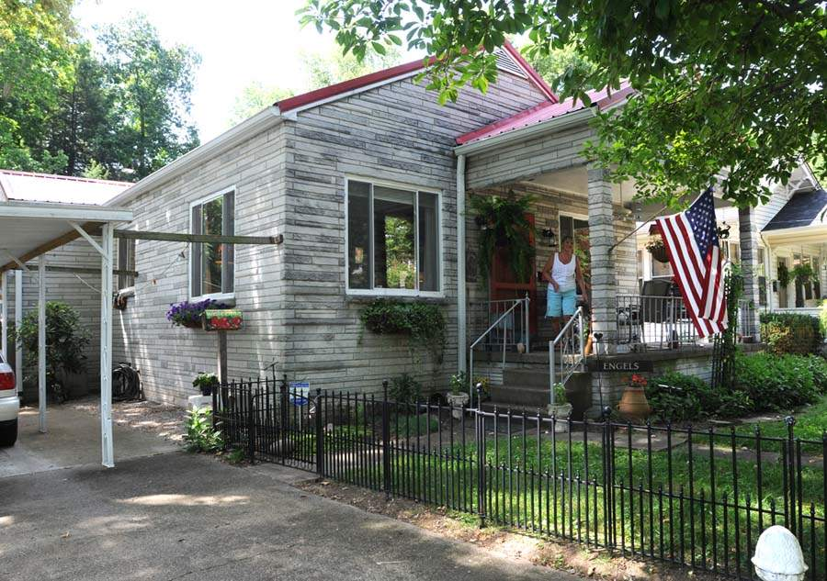
The century-old house on Valley Road contains 1,620 square feet. Carla Engels (on the porch) kept the exterior siding but replaced nearly everything else in the house.

Caregiver nurses shotgun house from 'dump'
By Rosalie Earle, Saturday, July 7, 2012, Charleston Gazette-Mail

Eight years ago, she paid $40,000 for a small house on Valley Road on Charleston's West Side. It was the ultimate fixer-upper.

The small shotgun house, built in 1901, had been home to one owner for 56 years. There was no central heating or air conditioning. Two gas fireplaces were supposed to heat the long, narrow house. The old windows rattled when the wind blew.

On first seeing this house, Carla Engels said she liked its wood floors and that it was on one level. She liked the large living room that spans the width of the house and the big windows that let in lots of light.

See more at: http://www.wvgazettemail.com/Life/201207070026#sthash.hQm82tEK.dpuf

Pursglove, West Virginia
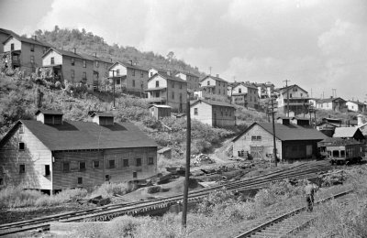
Marion Post Wolcott probably photographed Pursglove at the same time she documented nearby Chaplin. Here she has photographed two story "shotgun" houses on the hillside above mine shops and rail sidings. (Sep. 1938 image by Marion Post Wolcott, Library of Congress)
http://www.coalcampusa.com/nowv/fairmont/pursglove/pursglove.htm

