Virginia

Gloucester County, Virginia 3

Gloucester County, Virginia

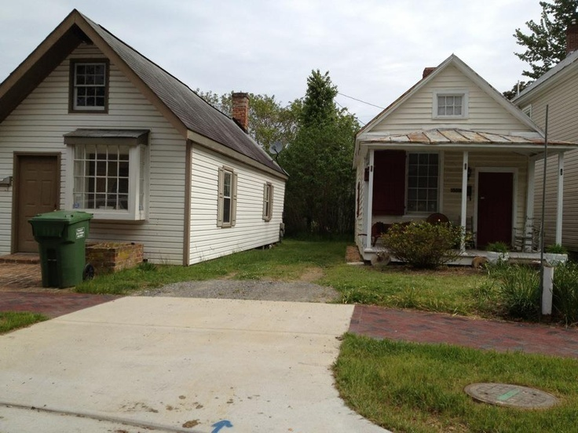

Shotgun houses in the middle of Gloucester County, Virginia...intriguing
Pinned by Kelly Bressler, We Shape Our Buildings
https://www.pinterest.com/kellyb137/we-shape-our-buildings/

