# 

**Utah**

Park City, Utah 3

## Park City, Utah

The angle of this photograph shows how the structure was long with no windows on the sides.

**Shotgun Style**

Strolling through Park City’s historic streets you’ll see an array of unique building types that emphasize the heavy hand that the mining era had on structural design, like the t-cottage or the pyramid style. But there also is an assortment of styles that are incredibly interesting and distinctive, like that of the a-frame and the shotgun style.

A shotgun house is very simple and typically has one room leading into the next without hallways and no windows on the sides. This style of house is believed to be well suited for hot climates because the front and back doors could be opened, and the breeze would flow through the entire house. This type of architecture has been documented as an African American contribution to American styles.

The style made its way to the American West in the late 19th to early 20th century and arrived in Park City not long after. This architectural style was not a common sight in Park City, with only three existing examples, however it was a staple in many other western mining towns.

The shotgun house at 413 Ontario Avenue is a good example of the architectural style. It has a long, lean base with no windows on the sides. The front porch provided space for shaded outdoor visiting. It was built by Charles Barnes in 1902. Mr. Barnes came to Park City from Rhode Island in 1890 to join his brother in jigging (separating crushed ore by agitating water on a concentrator table). He purchased the land lot in early March of 1902 and completed the house within the same year. He also purchased the adjoining lot at 417 Ontario and built another home. Both homes were built as investment properties, based on the speculation that the rental market would keep them afloat.

For more information, please call the Park City Museum at 435-647-7457 or visit our website at [www.parkcityhistory.org](http://www.parkcityhistory.org) . From: **Way We Were**, June 4, 2014, Sarah Hill, Research Librarian.

## Salt Lake City, Utah

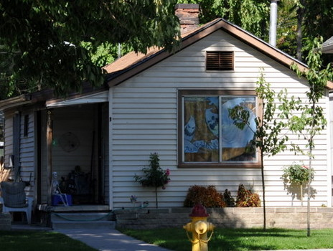

Shotgun Style home in Salt Lake City (author's photos)

Quite common in the southern United States and less common in the Western States is the Shotgun style house.

The shotgun house is one story tall, one room wide, and two or more rooms deep. This narrow home is associated with traditionally working class or Afro-American neighborhoods. In Utah, this typically means mining towns (Park City & Stockton, for example) and the downtown Salt Lake neighborhoods.

This style of home is not common in Salt Lake but a few are scattered in the Central City neighborhood of Salt Lake. Many of the Salt Lake shotgun style homes are modifications of the traditional design by including the front entrance on the side of the house rather than the front.

This style of home dates between 1875 and 1910.

Source: Thomas Carter & Peter Gross. 1991. Utah Historic Architecture 1847-1940.

<http://www.examiner.com/slideshow/architectural-profile-shotgun-house#slide=1>