Texas

Galveston, Texas 3
Houston, Texas 5
Waco, Texas 8

Galveston, Texas
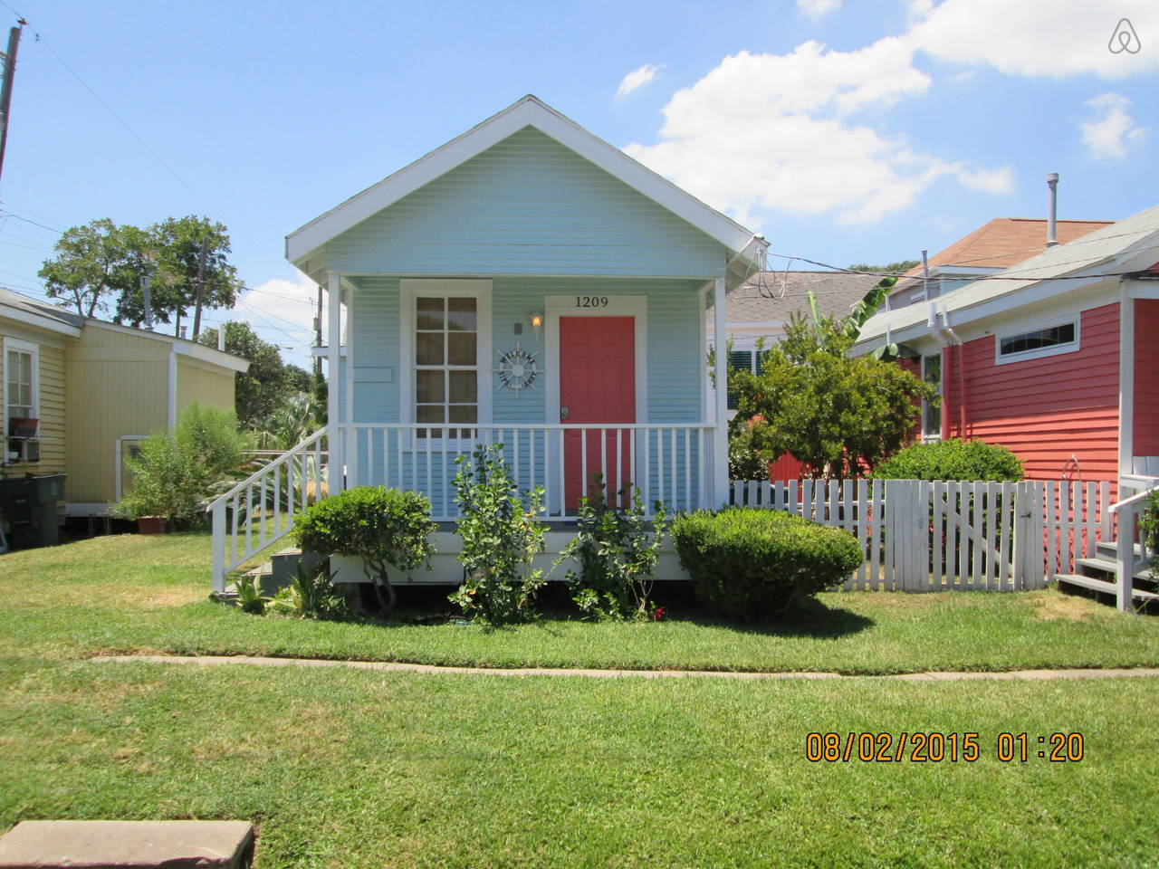

Restored historic shot gun house. Old charm with modern conveniences.

Airbnb, $99 per night

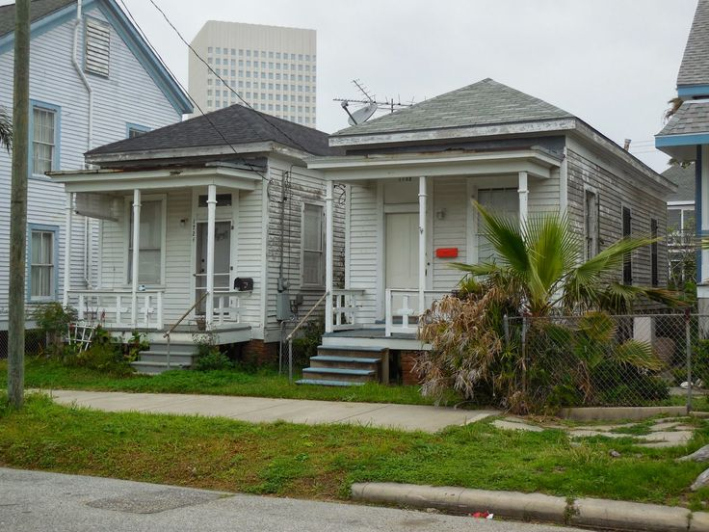

The next time you see those rows of small linear houses in poor neighborhoods, consider what you're really seeing. These are the remains of an African technology that reached considerable elegance among people of middle means in the 19th century.
And it's a technology that left an indelible and formative mark on our landscape. It propagated that outward-looking sign of community over America -- the front porch from which we've greeted friends and neighbors ever since.
No. 820: SHOTGUN HOMES AND PORCHES by John H. Lienhard

Houston, Texas
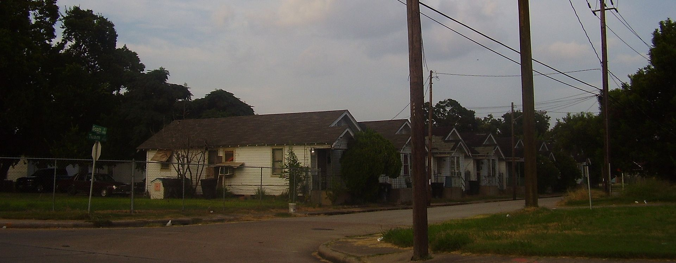
The portion of the Third Ward of Houston north of Truxillo has many shotgun shacks
"ThirdWardshotgunshacks" by WhisperToMe - Own work. Licensed under Public Domain via Commons - https://commons.wikimedia.org/wiki/File:ThirdWardshotgunshacks.JPG#/media/File:ThirdWardshotgunshacks.JPG
https://en.wikipedia.org/wiki/Shotgun_house
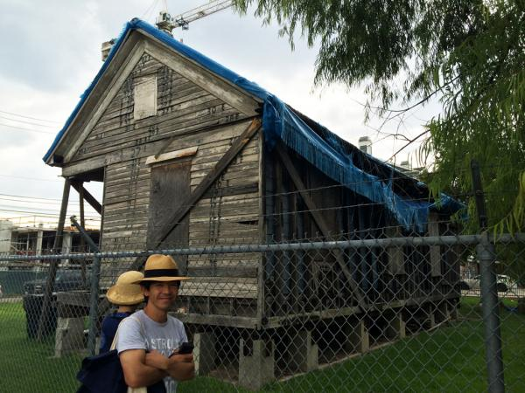
Visiting Houston's traditional shotgun houses

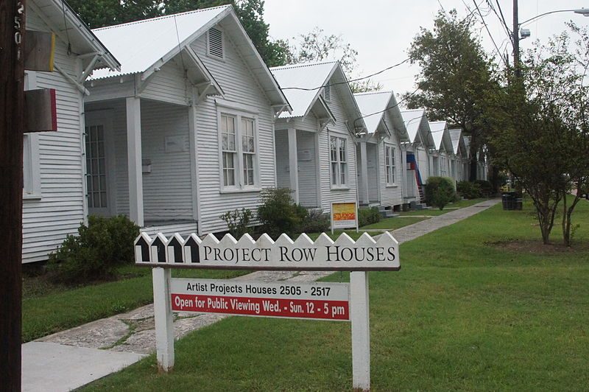
Project Row Houses in Third Ward Houston, Texas
https://upload.wikimedia.org/wikipedia/commons/f/f3/Project_Row_house_studios.JPG
https://en.wikipedia.org/wiki/Shotgun_house

Waco, Texas
This house in Waco, TX, was moved before the whole block was torn down for new development. Cameron & Jessie Bell found the 700 sf house and hired Chip & Joanna to move & rehab it. Quite a story. Love the before & after pictures.
http://www.hgtv.com/design-blog/shows/fixer-upper-tiny-home
https://magnoliamarket.com/shotgun-house/
