Tennessee

Knoxville, Tennessee 3
Memphis, Tennessee 5
Tallahasee, Tennessee 7

Knoxville, Tennessee
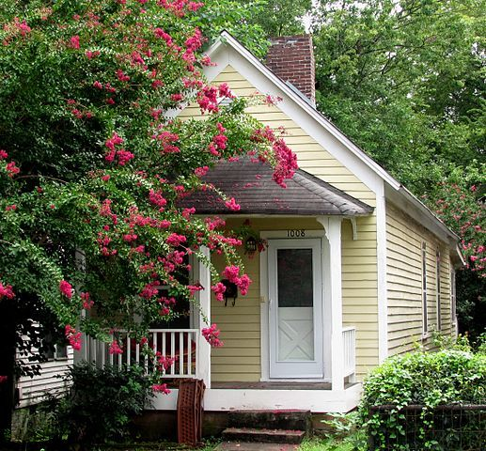

House at 1008 McGhee Avenue in the Mechanicsville neighborhood of Knoxville, Tennessee, USA. Built in 1910, this house is now a contributing property within the NRHP-listed Mechanicsville Historic District.
http://commons.wikimedia.org/wiki/File:1008-mcghee-knoxville-tn1.jpg – photo by: Brian Stansberry

See more at: http://www.house-crazy.com/a-blast-from-the-past-shotgun-houses/#sthash.nDk1P7QN.dpuf

Shotgun Houses
Of all historical housing forms found in Tennessee, the shotgun house is perhaps the least understood and most burdened with confusion and misconceptions. The shotgun sometimes represented the worst evidence of the treatment of the impoverished and, therefore, was viewed as simply a small house that afforded its occupants the first step in upward economic and social mobility.
It is ironic, then, that present real estate forces are exerting a significant influence on the preservation of the shotgun house in Tennessee. While a cluster of shotguns near downtown Jackson may be seen as slum housing, across town in the industrial suburb of Bemis owners and the community highly prize their shotgun houses. The same is true in other Tennessee towns, including Memphis, where shotgun neighborhoods are being demolished at the same time that shotguns in other areas sell readily for middle-class housing. Perhaps, as with all real estate, the perception of value is shaped more by location than by historical and architectural association.
December 25, 2009, By John Linn Hopkins and Marsha R. Oates
The houses usually provided worker housing, and are common in areas where working mills existed in the 19th century (Mechanicsville, Old North Knoxville and Edgewood-Park City).

http://tennesseeencyclopedia.net/entry.php?rec=660

Memphis, Tennessee
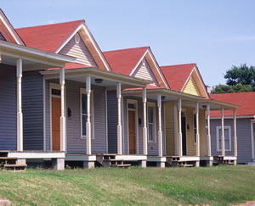

These historic shotgun houses in Memphis, Tennessee, have been rehabilitated for rental housing.
http://www.nps.gov/tps/tax-incentives/incentives/application_7.htm

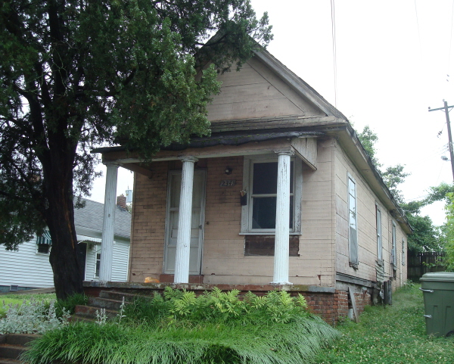

This particular structure was built around 1920 and is just less than 800 square feet.

In that not-so-distant past, the private real estate market did in fact produce large quantities of low-cost housing for poor and working-class Americans. The house pictured was not constructed for wealthy or middle-income persons of the 1920s, as their choice (at least in the south) was largely the bungalow or the foursquare. Thus, shotgun houses were "affordable," so to speak, from the moment they were built.

http://oldurbanist.blogspot.com/2011/01/idea-of-affordable-housing-part-i.html

Tallahasee, Tennessee
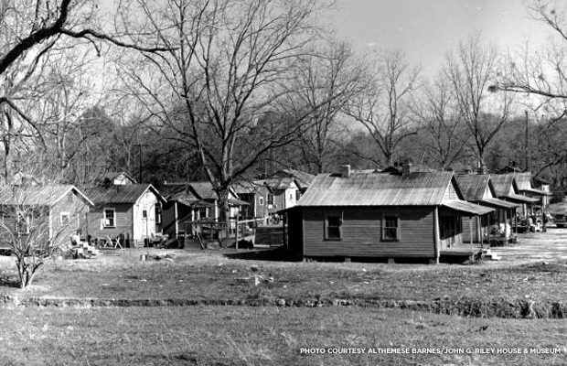
Part of the community of Smokey Hollow in 1963.
Smokey Hollow was a place where neighbors looked out for each other. Founded in the 1890s and located just east of downtown Tallahassee, employment and home ownership stayed high in this middle-class African-American community right up until the 1960s.
Then everything changed.
The land that Smokey Hollow stood on was slated for “urban renewal” by the state of Florida, meaning that it was prime real estate that could be annexed for an expansion of downtown Tallahassee or any number of other uses. Approximately 500 people lived in Smokey Hollow when it started to be “dismantled” in incremental steps, estimates Dr. Jennifer Koslow of Florida State University.
“Normally in urban renewal the federal government set aside money for mortgages [for new houses,]” says Koslow. “Most of the African-Americans were not afforded that opportunity. They did not receive either federal help or local help, and there was no public housing created for any of the people that were displaced.”
Of the neighborhood of shotgun-style houses that was once Smokey Hollow, only one street remains. So what was the land freed up from the destruction of this once-thriving community ultimately used for? Koslow explains that for the last 40 years, the space has mostly consisted of parking lots and neglected, empty space.
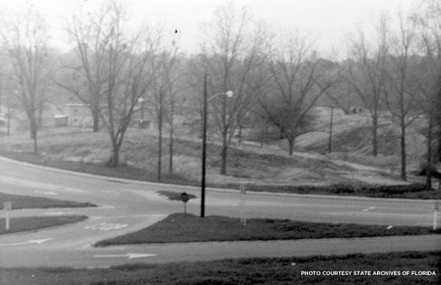
Another view of Smokey Hollow.
Smokey Hollow might have continued to fade into distant memory if not, in part, for the efforts of Althemese Barnes, the founding executive director of the John G. Riley House and Museum in Tallahassee. The house was the former home of educator John G. Riley, a man who was born enslaved in 1857 and died a millionaire in 1954.

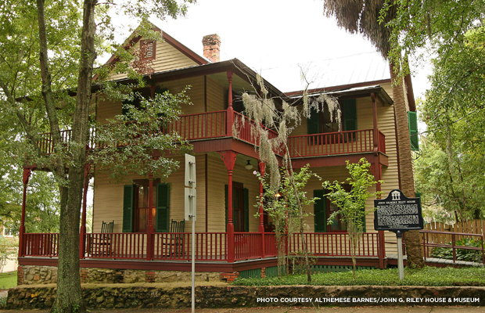
The John G. Riley House Museum in Tallahassee, Fla.
Placed on the National Register of Historic Places in 1978 and purchased by the John G. Riley Foundation in 1982, the house opened as the John G. Riley Center and Museum of African American History and Culture in 1996. For years, it was the only existing monument to Smokey Hollow's prosperous heyday.
In 2009 the city of Tallahassee and local government development agency Blueprint 2000 started work on Cascades Park, a 24-acre green space built in the footprint of Smokey Hollow. When Barnes learned of plans for the park, she felt that these plans needed to include some kind of commemoration of the formerly vibrant community that had once stood in the same space.
“I contacted former residents of Smokey Hollow and had to break through a lot of anger and bad feelings,” says Barnes. She used their input to shape the interpretation of Smokey Hollow’s history that would be included in the new park.
Barnes’ vision will finally begin to come to fruition in early 2014 with the opening of Smokey Hollow Village, a group of three “spirit houses,” or replicas of the shotgun houses that were once characteristic of Smokey Hollow. The houses will feature interpretive panels with information about the history of the community and will be built without walls so that visitors can move between them freely. A grand opening of a brand-new visitors' center is also scheduled for the end of September.
Phase II and Phase III of the project include a walking trail from the site of the spirit houses to the Riley museum, interpretive signage scattered throughout the park, and a new pavilion for visitors.
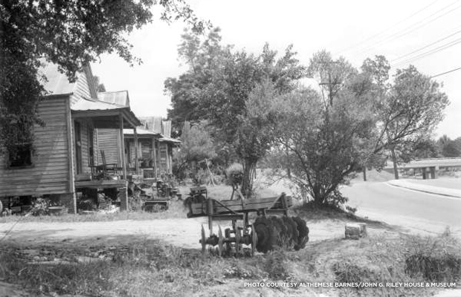
The former Meridian Street in Smokey Hollow, circa 1958.
Barnes, with help from a committee comprised of Dr. Jennifer Koslow and others, also spearheaded efforts to have a Historic American Landscapes Survey done to commemorate Smokey Hollow. Once completed, the survey will be filed in the Library of Congress.
"It took many of us to develop and build Tallahassee," says Barnes of the importance of documenting the neighborhood's history. "Much of the work force back then [in the town's early days] were people out of Smokey Hollow."
Although it’s difficult to repair the damage caused by destroying people's homes and way of life, Koslow sees the new developments as steps in the right direction.
“The community [outside Smokey Hollow] is definitely trying to rectify what they see as a wrong,” she says. “This argument about urban renewal, it destroyed a vibrant, living community.”
Katherine Flynn is an assistant editor at Preservation magazine. She enjoys coffee, record stores, and uncovering the stories behind historic places.
National Trust for Historic Preservation
Clearing the Air: Commemorating Tallahassee's Smokey Hollow Community
By Katherine Flynn, September 11, 2013
https://savingplaces.org/stories/remembering-smokey-hollow#.Vv4FS3o9-So

