South Carolina

Columbia, South Carolina 3

Columbia, South Carolina

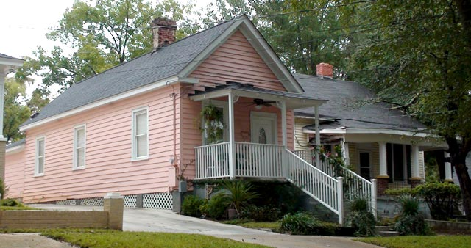

1724 Wayne Street

Typically, parlors were located in the front, kitchens in the rear, and bedrooms in between. This modest plan suited narrow urban lots, and houses of this style once were prevalent throughout areas of Arsenal Hill that lay closer to Huger Street.

http://www.historiccolumbia.org/Media/Default/RETRACE%20Tours/Arsenal%20Hill/site16-shotgun-house.jpg

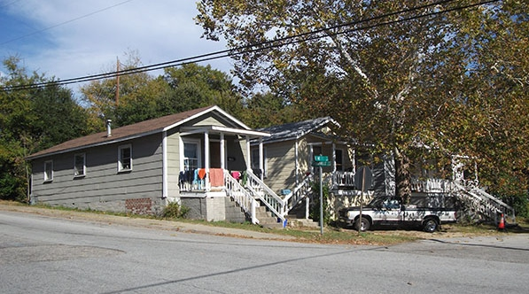
View east at the corner of Barhamville and Matthews Streets in 2015.

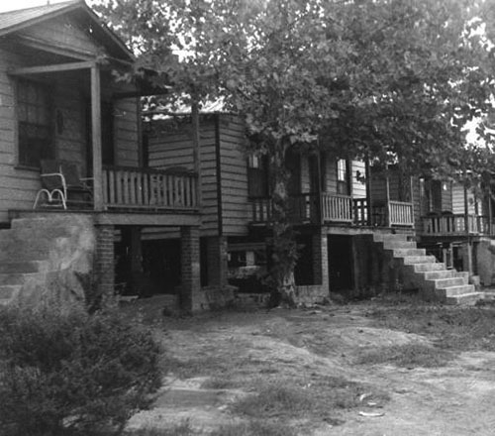
View east down the 2400 block of Matthews Street in 1956
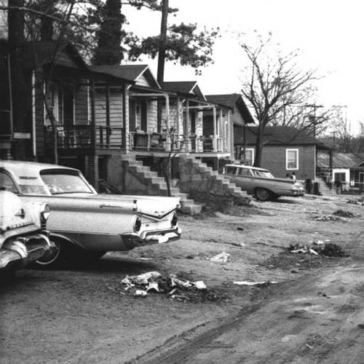
View east down the 2400 block of Matthews Street in 1966
Images courtesy of Joseph Winter Collection, South Caroliniana Library
Known as George Street until 1944, Matthews Street possesses several intact examples of the “shotgun” house, a domestic vernacular style historically common throughout the South. The shotgun house, popular from 1880 to 1930, was distinct for its narrow, rectangular form, usually one room wide and two rooms deep. This domestic style often populated modest or low income urban Southern neighborhoods and was once a more prominent presence on the streetscape of Columbia. Some historians trace the origin of the shotgun house to African and Haitian influences in New Orleans, where they subsequently were adopted by black freedmen who migrated to cities across the South.
http://www.historiccolumbia.org/tour-locations?neighborhood=Barhamville-Kendalltown

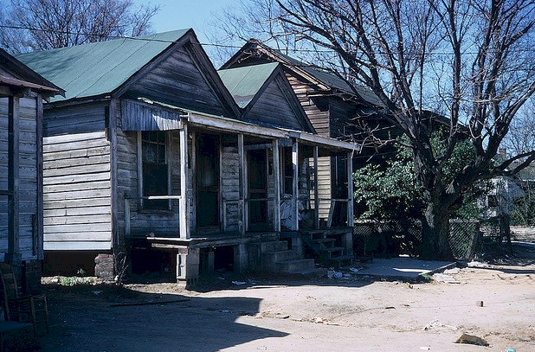

Typical black shotgun homes of Columbia during the first half of 20th Century. The blacks who lived in the Lincoln Street area, also known, for some ironic reason, as White Town, lived in unpainted shotgun houses, sitting on stone stilts along narrow unpaved dirt streets. Their homes came with no screened doors, no window screens, no electricity, no indoor water, and no indoor sewer system. Their water came from a common tap at the end of each street, and every back yard had that house behind the house. In the steaming heat of the South Carolina summers they would sit on their porches and stoops talking about events of the day and swapping rumors. About every other house would have a rusty oil drum with a smoking fire burning to help ward off the mosquitoes.
by Larry Chapman, http://www.lechap.com/2011/10/boswells-grocery-a-bygone-reality/

