Pennsylvania

McKeesport, Pennsylvania 3
Philadelphia, Pennsylvania 5

McKeesport, Pennsylvania
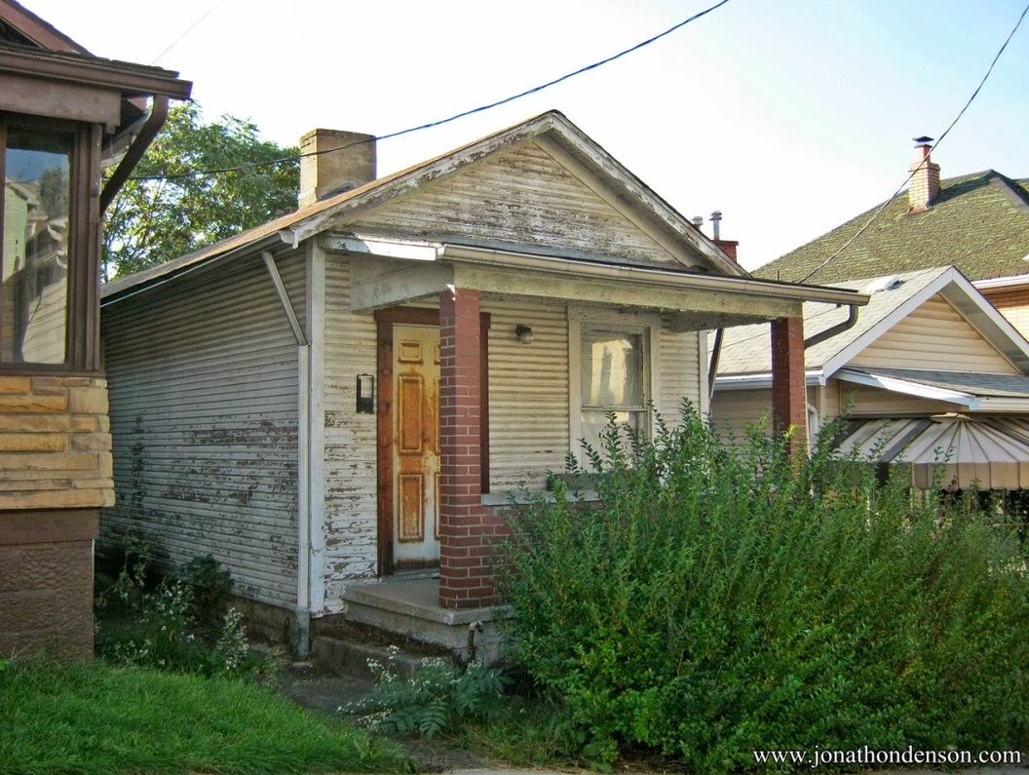
Did you know that "Shotgun" houses existed in the North? These narrow, modest worker homes are located on Scott Street and Scott Street Rear in McKeesport, PA. It is something of a miracle that they have survived. They probably date to the early 20th century.

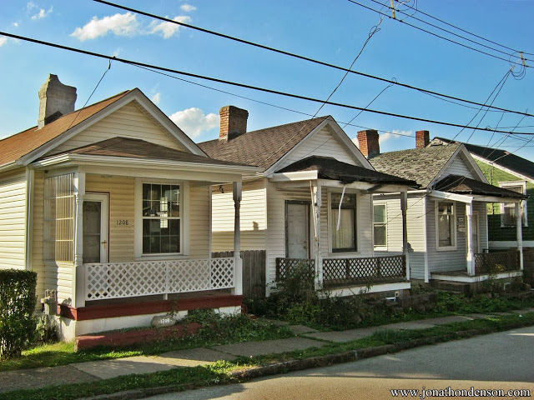
From: http://www.jonathondenson.com/2013_10_01_archive.html

Philadelphia, Pennsylvania
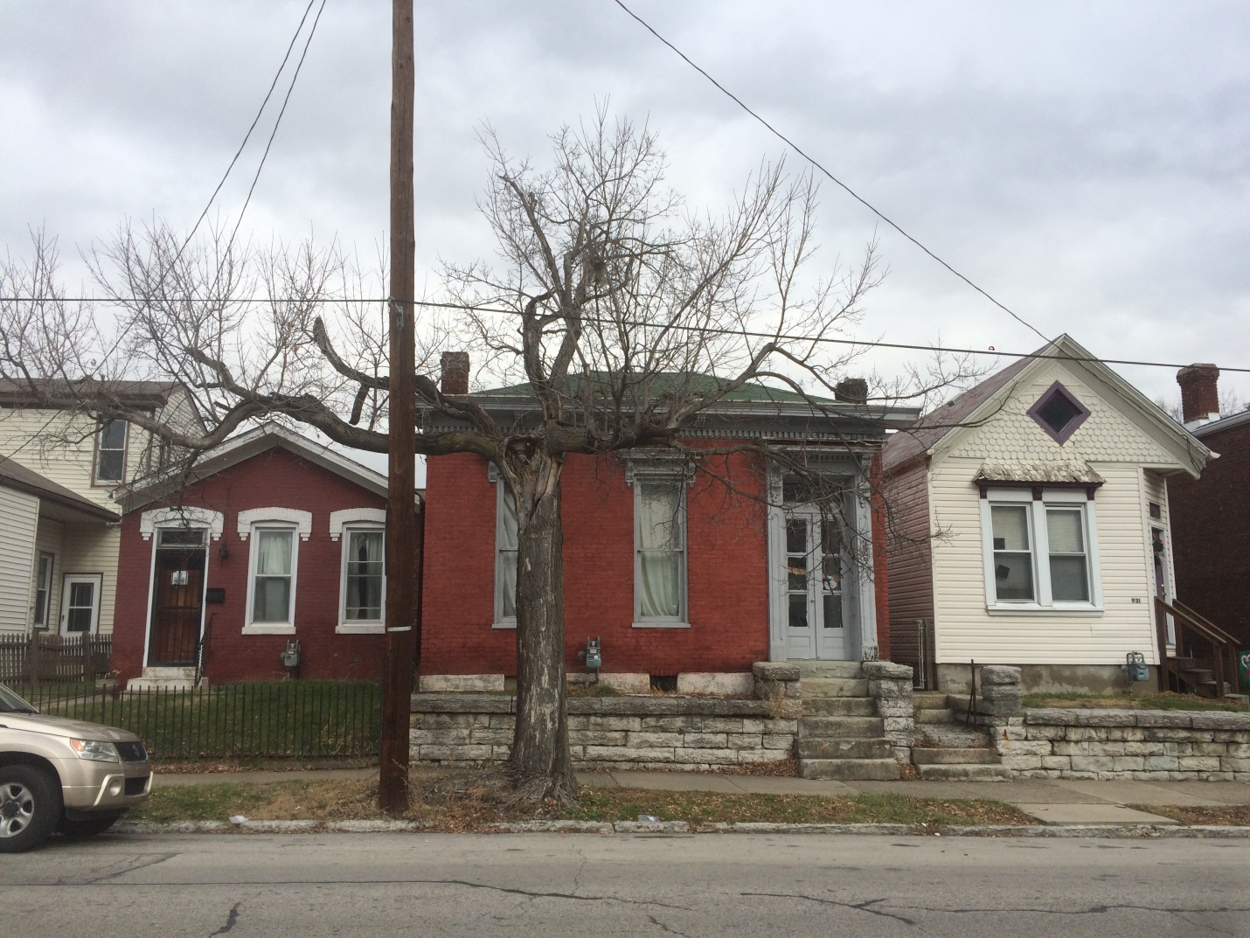
Shotgun houses in historic Germantown neighborhood of Philadelphia
https://www.pinterest.com/pin/482448178807923657/

