Oregon

Bourne, Oregon 3
Lebanon, Oregon 4
Shevlin, Oregon 5

Bourne, Oregon
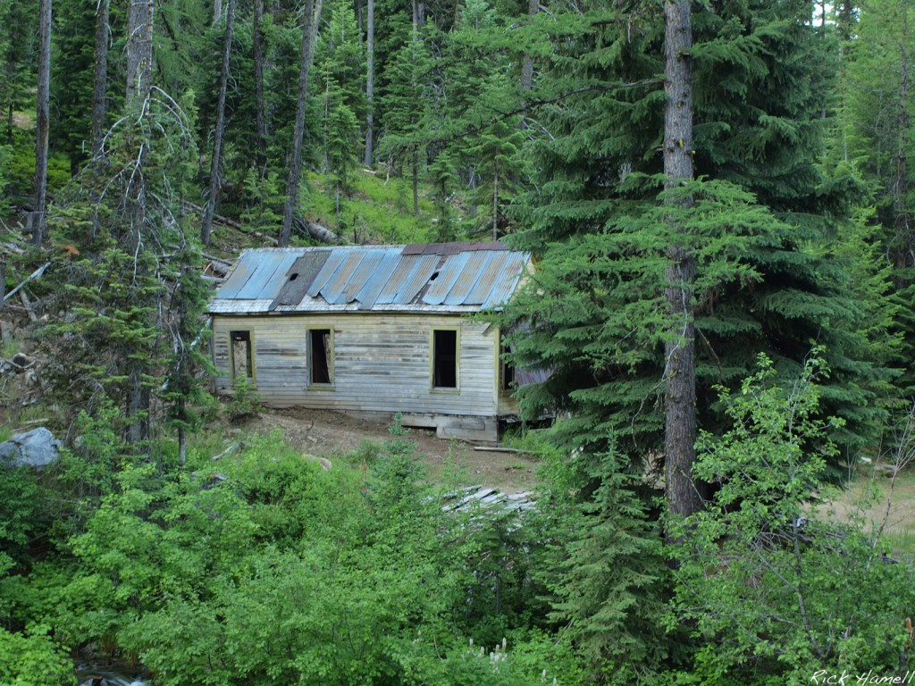
Ghost Town of Bourne, Oregon (Cracker), July 25, 2011, Pacific Northwest Photoblog
http://pnwphotoblog.com/wp-content/uploads/sites/11/2011/07/House2-1024x768.jpg
http://pnwphotoblog.com/ghost-town-of-bourne-oregon/

Lebanon, Oregon
By Finn J.D. John — August 25, 2013
Not long ago, I bought a fixer-upper house in Lebanon, a little boxy thing on the outskirts of town, that needed help. As it turned out, it needed a lot more help than I had envisioned (funny how that happens); one of the things it needed was to be jacked up so that a proper foundation could be poured under it. In the process of doing this, I discovered that the underside structure of the house was very unusual. It appeared to have started out as a small shoebox-shaped structure, 22 feet long and 14 feet wide, but built very stoutly; the rest of the house had been added onto that box, apparently in four separate phases, until the house was 27 by 20 feet in overall size. (You can imagine how much fun it was to keep all that stable while jacking the house up.)
But the central part of the house had some odd characteristics. The floor joists were rough-sawn 2x10s, which is insane overkill for such a tiny building; the ceiling joists, 2x8, ditto. But the weirdest thing was the floor joists ran not side to side, as is usually done when building a house, but lengthwise -- they ran 22 feet from one end of the house to the other.
It wasn't until I started doing the research for [this Offbeat Oregon] story that I realized that the house I bought was one of the family residences from the town of Shevlin. Those extra-stout floor joists, running lengthwise, were to keep the house from cracking or twisting when the crane operator lifted it onto a rail car.
You would not recognize the place now, of course. It's quite a lot bigger, and also has (ahem) running water. But in the core of this little house, the main rooms are still composed of a little piece of Central Oregon history. Cool, huh?

Shevlin, Oregon
Excerpt from Oregon's wandering timber town by Finn J.D. John — August 25, 2013
The little logging-company town, owned by the Shevlin-Hixon Company of Bend, was fully portable. When the timber was all gone from an area, the company simply loaded the houses on railroad flatcars and moved on.
In 1932, the Shevlin-Hixon Company decided to consolidate all its logging camps into one big one. They’d plat it with streets, blocks and lots. They’d endow the camp with plenty of family housing, a store, a post office, a barber shop and a school district. In other words, they’d turn it into a full-blown small town.
And thus, the town of Shevlin was born.
Life in Shevlin
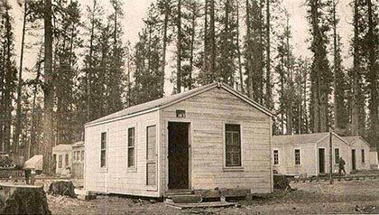
One of the railroadable family houses of the type later used to house logger families at Shevlin. The houses were divided into two rooms. (Image: Ronald L. Gregory)
Residents of Shevlin tend to remember it fondly. Deep in the heart of Central Oregon, it was close to the kind of back-woods recreation that Oregon timber families have always loved: fishing, hunting, trekking, camping, swimming in cold alpine lakes, that kind of thing. There were no telephone bills or even rent payments to worry about. The isolation fostered a strong sense of community, and that sense extended to the owners and managers of the company — who, when the Great Depression gobsmacked the lumber market, helped the families get through by spreading the work around so that everybody got enough to survive.
On the other hand, anybody who got fired was in a terrible pickle, which gave the company rather a strong hand in the event of any labor disagreements.
The houses were quite Spartan by modern standards. In the early years, they were basically boxcars with no wheels; but as the 1920s wore on and it became necessary to provide an environment that mothers would tolerate, the houses changed. By the 1930s they had gabled roofs, six windows and specially designed front porches that folded up against the side of the house on moving day. They were 14 feet wide and 22 feet long, divided into two rooms, with the front entrance at one end, shotgun-house style.
Moving day
Shevlin moved three times, each time going farther south, away from Bend. Company planners would scout a new location, and roads and lots would be bulldozed, and latrine pits would be dug. Then, over a few days, the entire town — some 400 structures — would be hauled in and the homes set in place. Outhouses brought from the old townsite would be set down over the top of new latrine pits, and everybody would move right back in. It must have been a fairly disorienting experience for newcomers.
Moving day was a big deal. Most residents got to preview the new site and pick the lots their houses would be placed on. Then the front porches would be folded up, the windows covered and the houses prepped for the lift. Dressers would be laid flat on the floor, and towels wrapped around the dishes, but the company crane operators were pros — accidents were few. Postmistress Lois Maker Gumpert once left a bucket of water in the middle of the floor by accident, and when her house arrived at its new spot, not a drop had spilled.
The end
Of course, the end came for Shevlin. It had to come. Right from the start, Shevlin-Hixon seemed completely uninterested in sustainable forestry. It was essentially a mining company, and once it had mined all the usable timber out of an area, it was done: no replanting, no thinning, none of that modern tree-farming stuff. Cut-over company lands were left to re-seed themselves, and the second growth, when it eventually came, was in the form of dense “dog-hair” thickets that had no commercial value.
In 1950, its endowment of ponderosa nearly depleted, the company sold out to Brooks-Scanlon, and Brooks-Scanlon was not interested in the company-town system of timber extraction. Before the end of that year, it sold off all the buildings, and the town was gone.
But it’s a sure thing that somewhere around Central Oregon, there’s a family or two still living in one of the old railroad houses that used to line its streets — wherever those happened to be.
(Sources: Gregory, Ronald L. Life in Railroad Logging Camps of the Shevlin-Hixon Company. Corvallis: OSU Anthropology Dep’t, 2001; Carlson, Linda. Company Towns of the Pacific Northwest. Seattle: UW Press, 2003; Terry, John. “Logging Town of Shevlin ...,” Portland Oregonian, 28 Aug 2010)
http://offbeatoregon.com/1308d-shevlin-oregons-wandering-timber-town.html

