Oklahoma

Oklahoma City, OK 3
Sand Hills, Oklahoma, Sand Springs Widow’s Colony 6

Oklahoma City, OK
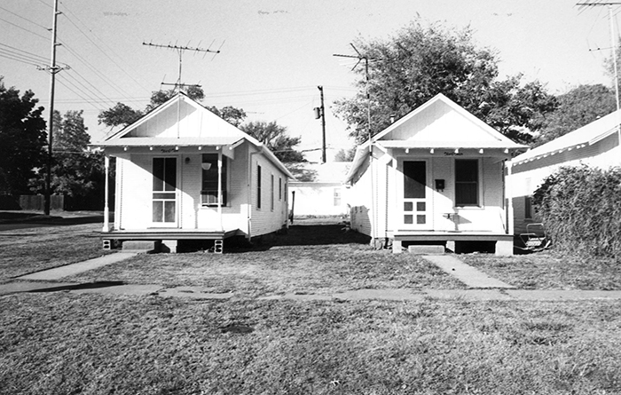
Shotgun house (G. Carney photo) State Historic Preservation Office
Oklahoma History Center | 800 Nazih Zuhdi Drive, Oklahoma City, OK 73105 | 405-521-2491 Site Index |
The shotgun house is one of the most prevalent and persistent types of folk architecture in Oklahoma. Like shotguns found elsewhere, it is one room wide, two or more rooms deep, and one story high, and it has a door in each end. The name derives from the belief that shotgun pellets fired through either the front or rear entrance could pass through the entire house without damaging the interior; however, in many shotguns the front and rear doors were offset. Although its origins are disputed, the shotgun is believed to have emerged in New Orleans in the early nineteenth century. In Oklahoma its presence is attributed to various cultural groups that settled the state from the 1840s onward.
Historically associated with the development of the shotgun house in the American South, African Americans served as diffusion agents for the type as Oklahoma was settled. First, black slaves came to Indian Territory with the Five Civilized Tribes in the 1830s. Plantation agriculture, based on cotton and slave labor, continued as the dominant economic activity. Second, in the 1890s throughout the South, Oklahoma Territory was promoted as an All-Black state. As a result of migration, more than fifty All-Black towns and settlements appeared in Oklahoma and Indian territories. Lending credence to the diffusion theory are extant shotguns in African American neighborhoods in former cotton-oriented communities in southern Oklahoma, as well as in several of the remaining All-Black towns.
Two occupational groups aided the spread of the shotgun house throughout Oklahoma. In the early 1900s the lumber and petroleum industries developed, drawing hundreds of transient laborers from Texas and Louisiana. Loggers and sawyers built dozens of shotguns in logging camps and in company towns, such as Wright City, in southeastern Oklahoma's forests. With the opening of the Glenn Pool oil field in 1905, boom-chasers, especially rig builders, carried the shotgun idea from the oil fields of Louisiana and Texas. As workers moved from field to field, shotguns appeared, and many are still used in former boomtowns of the Cushing, Seminole, and Burbank oil districts. A large section still exists in Oklahoma City south of the North Canadian River.
Petroleum and lumber companies found the shotgun economical and practical. It was quickly assembled, it required neither blueprints nor skilled carpenters, it used locally available and inexpensive materials, and it was portable and durable. The houses could be either loaded intact on railroad flatcars or quickly disassembled into six or eight pieces (roof, walls, floor, and room partitions) and relocated to or rebuilt on a new site. It was used primarily for sleeping, because work continued around the clock, with laborers sleeping in eight-hour shifts. In Oklahoma the shotgun house thus became a "workingman's cottage."
In Oklahoma's built environment the shotgun house has remained a viable element for more than a century, its unexpected longevity deriving from its size and design. The single, uninsulated walls provide no dead air space for trapping moisture that deteriorates wood. The box-like shape places equal stress on the four corners and prevents leaning or sagging. The unit's low profile prevents destruction from the high winds and tornadoes common in Oklahoma. Constructed as temporary, semipermanent housing, the shotgun has stood the test of time to become a significant house type in the state's folk architecture.
George O. Carney
George O. Carney, "Shotgun House," Encyclopedia of Oklahoma History and Culture, www.okhistory.org (accessed December 31, 2015)
http://www.okhistory.org/publications/enc/entry.php?entry=SH028

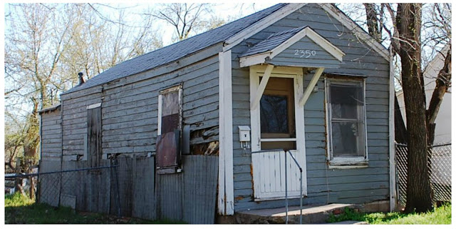
A shotgun house in Oklahoma City’s Little Mexico.
From Are you there God? It’s Me Generation X.
http://www.jenx67.com/2013/04/seeking-out-the-poorer-quarters-in-okcs-little-mexico.html

Sand Hills, Oklahoma, Sand Springs Widow’s Colony
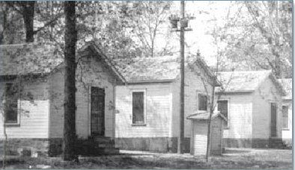
The original Sand Springs Widow's Colony had shotgun houses all in a row. The houses, which were easy to build, helped out families in need.

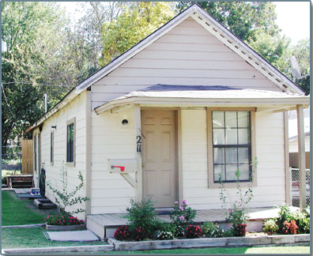
A shotgun house at 211 N. Grant Ave. is one of many still scattered around Sand Springs. The houses were originally built for industrial workers and also for the Sand Springs Widow's Colony.

Shotgun house history examined in Sand Springs
They called them shotgun houses. If you stood at the front door, you could shoot a gun and hit the back door.
The residences served as comfortable homes for everyone from industrial workers in Sand Springs, to people living in the Sand Springs Widow's Colony.
Originally of West African origin, the shotgun house first appeared in New Orleans via the Caribbean sugar islands. Beyond those communities, the shotgun house emerged as an icon of the cotton plantations in the South, where it served as slave quarters and sharecropper housing, according to information provided by Brad Bays, a professor at Oklahoma State University.
At the end of the 19th century, the shotgun house was adapted as worker housing in the mines and oil fields of the south, Bays said.
Ruth Ellen Henry, program coordinator, with the Sand Springs Museum, said the houses are part of the city's history.
"This community was a planned industrial community so that everything would work together to establish this perpetual trust that would provide for widows, their children and orphans for years and years to come," she said. "And it's worked. We're proof of that."
She said many of the 750- to 900-square foot houses have been torn down, but there are still at least 50 to 100 left in Sand Springs. Their popularity boomed in the beginning because they were easy to build.
Between 1910 and 1920, the houses sprung up for people flocking to jobs on the railroad, cotton mills and glass plant. One section was called mill row because of the many mill workers who lived in the homes.
"Some of the neatest people that ever lived, lived in the shotgun houses. There were many cultural diversities," Henry said. "They've seen lots of babies and lots of successful people come out of those houses."
Principals, teachers, a city councilor and a Vietnam War hero are just a few who were reared in shotgun houses.
The Sand Springs Widow's Colony also implemented shotgun houses. The colony, started by Sand Springs founder Charles Page, took in widows and their children. The need for housing was so great that rows of shotgun houses were erected.
Jane Luce, who lived in the Widow's Colony from 1946 to 1955, said she was one of six children who lived in the three-room house with their mother.
She described being able to see all the way to the back door from the front door. Her house also had a front and a back porch.
"We were happy that we could live together. Yes, I have good memories," Luce said.
Henry said it's amazing how small the homes were and how many people could live in them and somehow have a good life.
"They knew how to make due with what they had. Children from the Widow's Colony still say today they had a good home," she said.
"It was just another subdivision. It wasn't that 'those poor people have to live there.'"
By Kristina Dudley World Staff Writer , Tulsa World, Wednesday, October 6, 2004

http://www.tulsaworld.com/archives/shotgun-house-history-examined-in-sand-springs/article_7759d4bc-11c2-5d4d-9e07-5e5c90ae4268.html

