Ohio

Columbus, Ohio 3

Columbus, Ohio
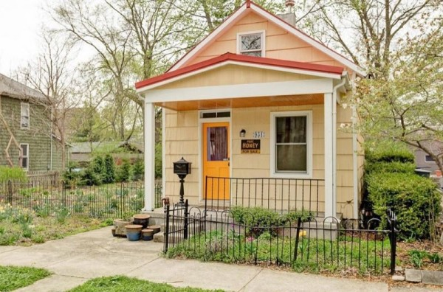
750 sq. ft. one bedroom, one bathroom small cottage in Columbus, Ohio that was built in 1920.
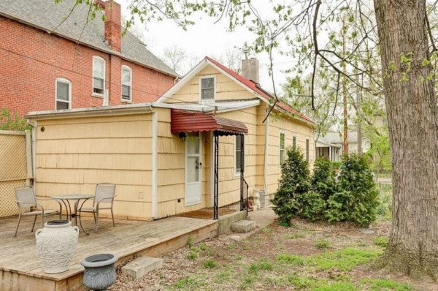
Read more at http://tinyhousetalk.com/750-sq-ft-small-cottage-columbus-ohio/#MGTKKaHb3X7LhtVP.99

