North Carolina

Charlotte, North Carolina 3
Wilson, North Carolina 7
Winston-Salem, North Carolina 8

Charlotte, North Carolina
2 Humble ‘Shotgun’ Houses Moving Into Cultural Spotlight
"Shotgun" House, Charlotte Observer January 28, 1986
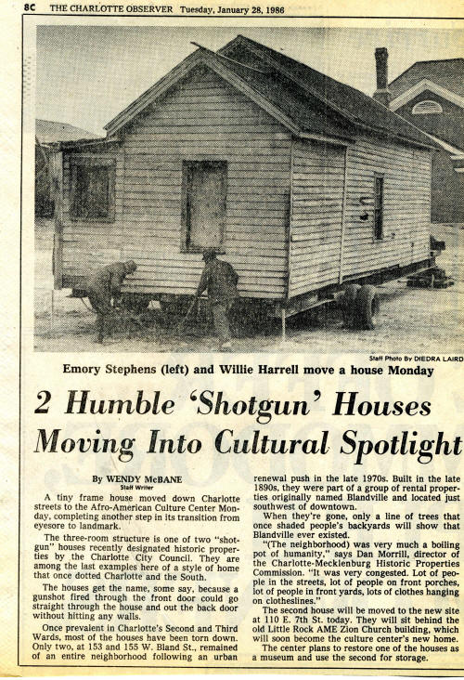
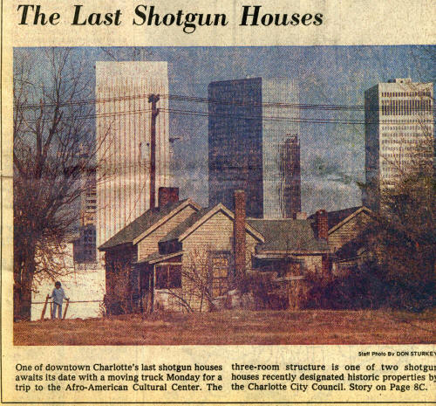

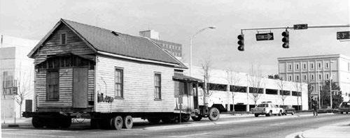

Shotgun house en route to its new location

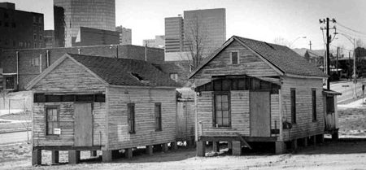
Shotgun houses at their new location behind the Old Little Rock AME Zion Church.
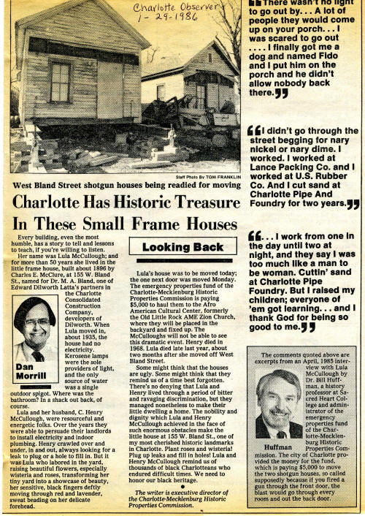

http://www.cmhpf.org/S&Rs%20Alphabetical%20Order/surveys&rshotgun.htm
http://www.carolinacorner.com/attractions/shotgun-houses.htm
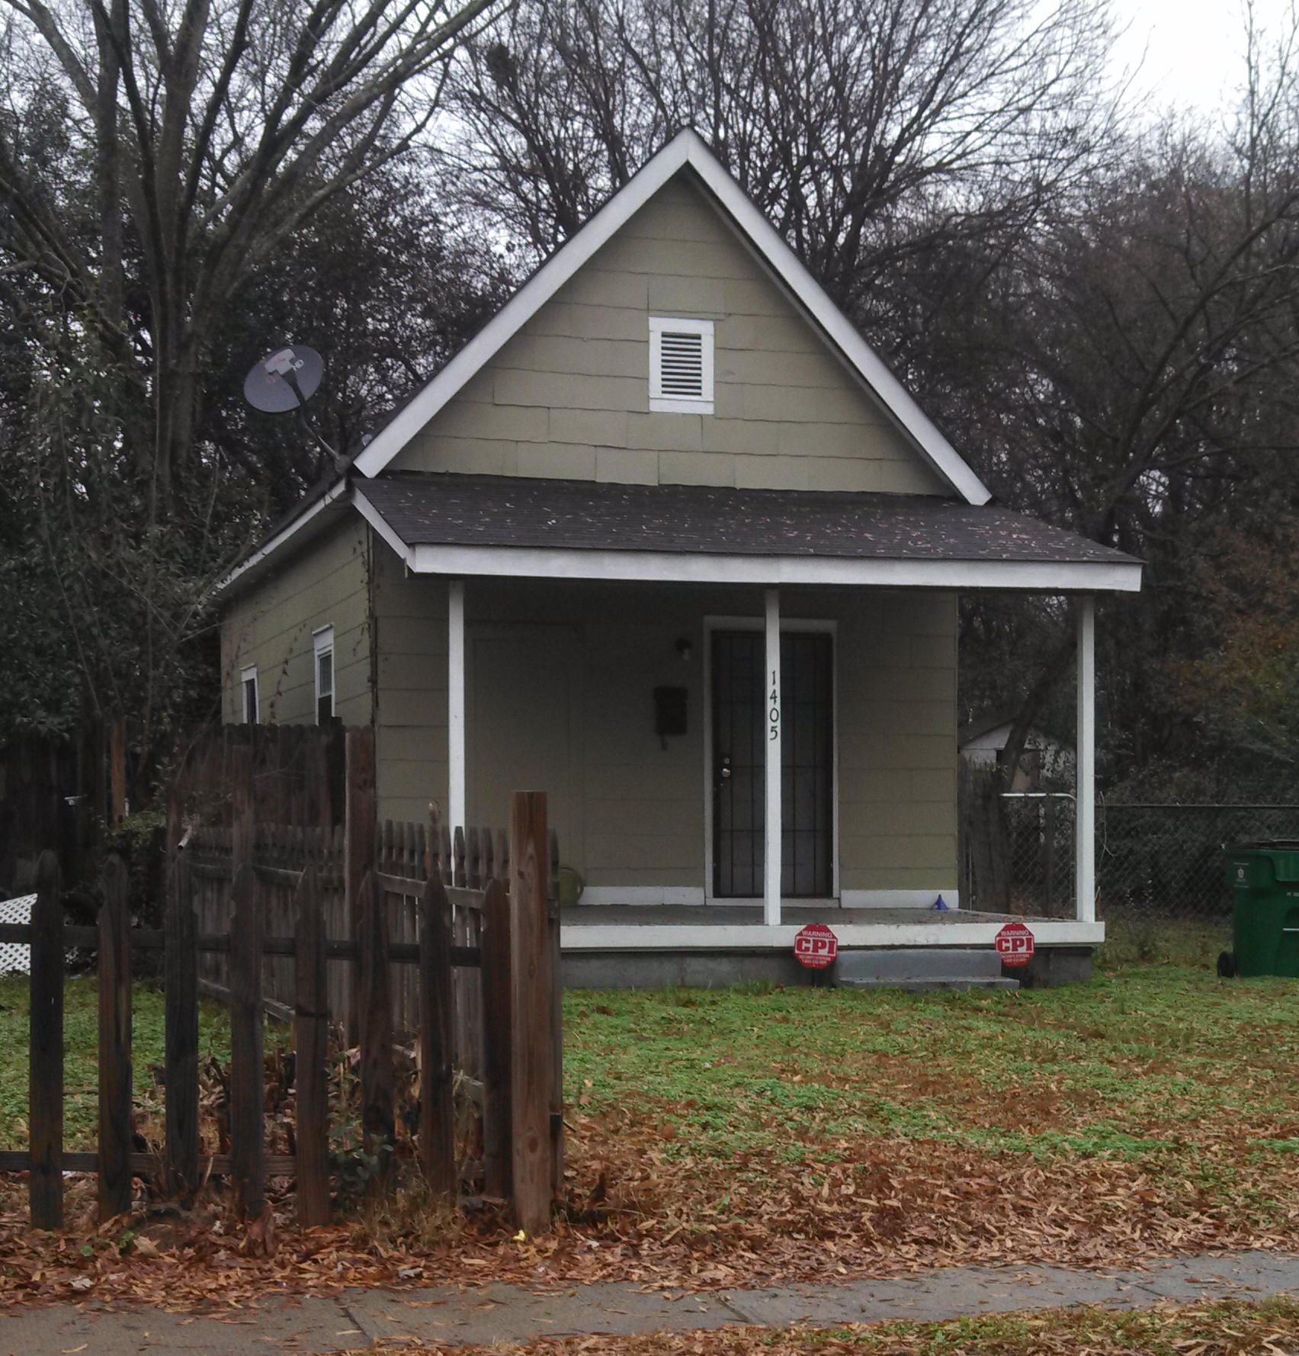
Belmont Shotgun House, 1405 Kennan Street, Charlotte
The Survey Committee presents a seconded motion to The Historic Landmarks Commission that the Belmont Shotgun House, 1405 Kennan Street, Charlotte, N.C., be placed on the study list of prospective historic landmarks.

Wilson, North Carolina
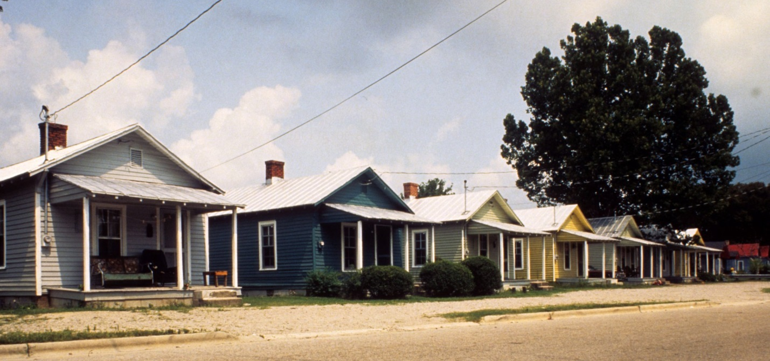
View, Vick Street houses,
Tim Buchman Photographs, 1988-1998
http://d.lib.ncsu.edu/collections/catalog/buch0657

Winston-Salem, North Carolina

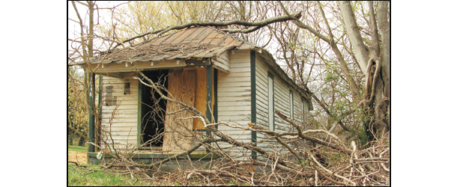

pictured above: The house at 716 Humphrey St.)
The city is seeking developers to restore the two surviving shotgun houses in the historic Happy Hill community.
Long vacant, the houses – both on Humphrey Street and dating back to the early 20th Century – are owned by the city.
The house at 716 Humphrey St. still sits on its original foundation and was acquired by the City in 2006.

http://www.wschronicle.com/2014/06/city-wants-new-life-for-shotgun-houses/

