North Carolina

Charlotte, North Carolina 3
Wilson, North Carolina 7
Winston-Salem, North Carolina 8

Charlotte, North Carolina
2 Humble ‘Shotgun’ Houses Moving Into Cultural Spotlight
"Shotgun" House, Charlotte Observer January 28, 1986
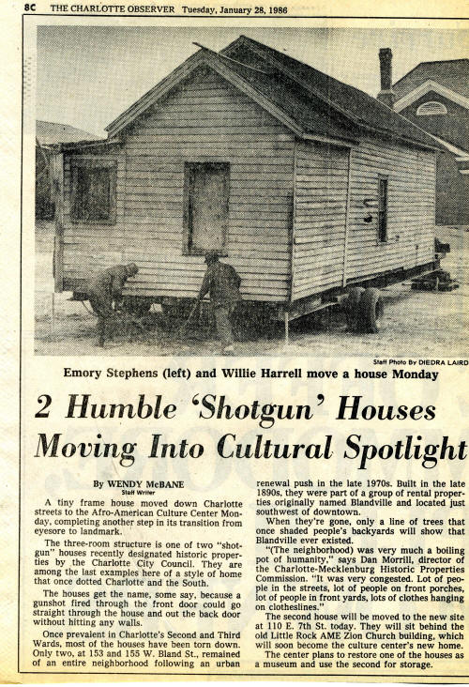
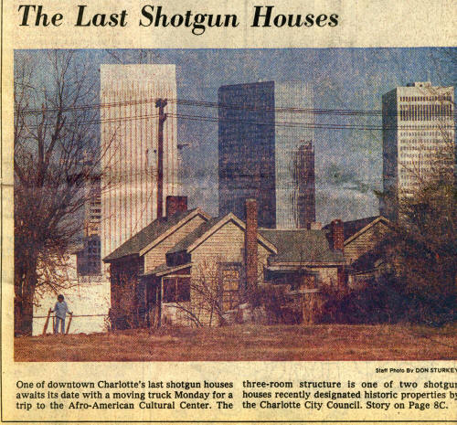

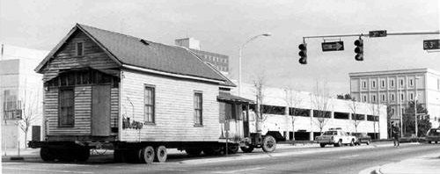

Shotgun house en route to its new location

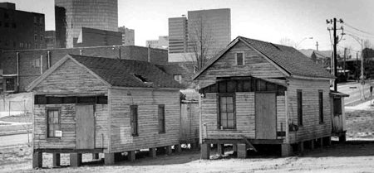
Shotgun houses at their new location behind the Old Little Rock AME Zion Church.
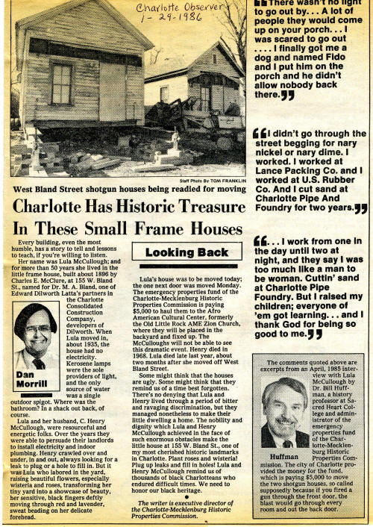

http://www.cmhpf.org/S&Rs%20Alphabetical%20Order/surveys&rshotgun.htm
http://www.carolinacorner.com/attractions/shotgun-houses.htm
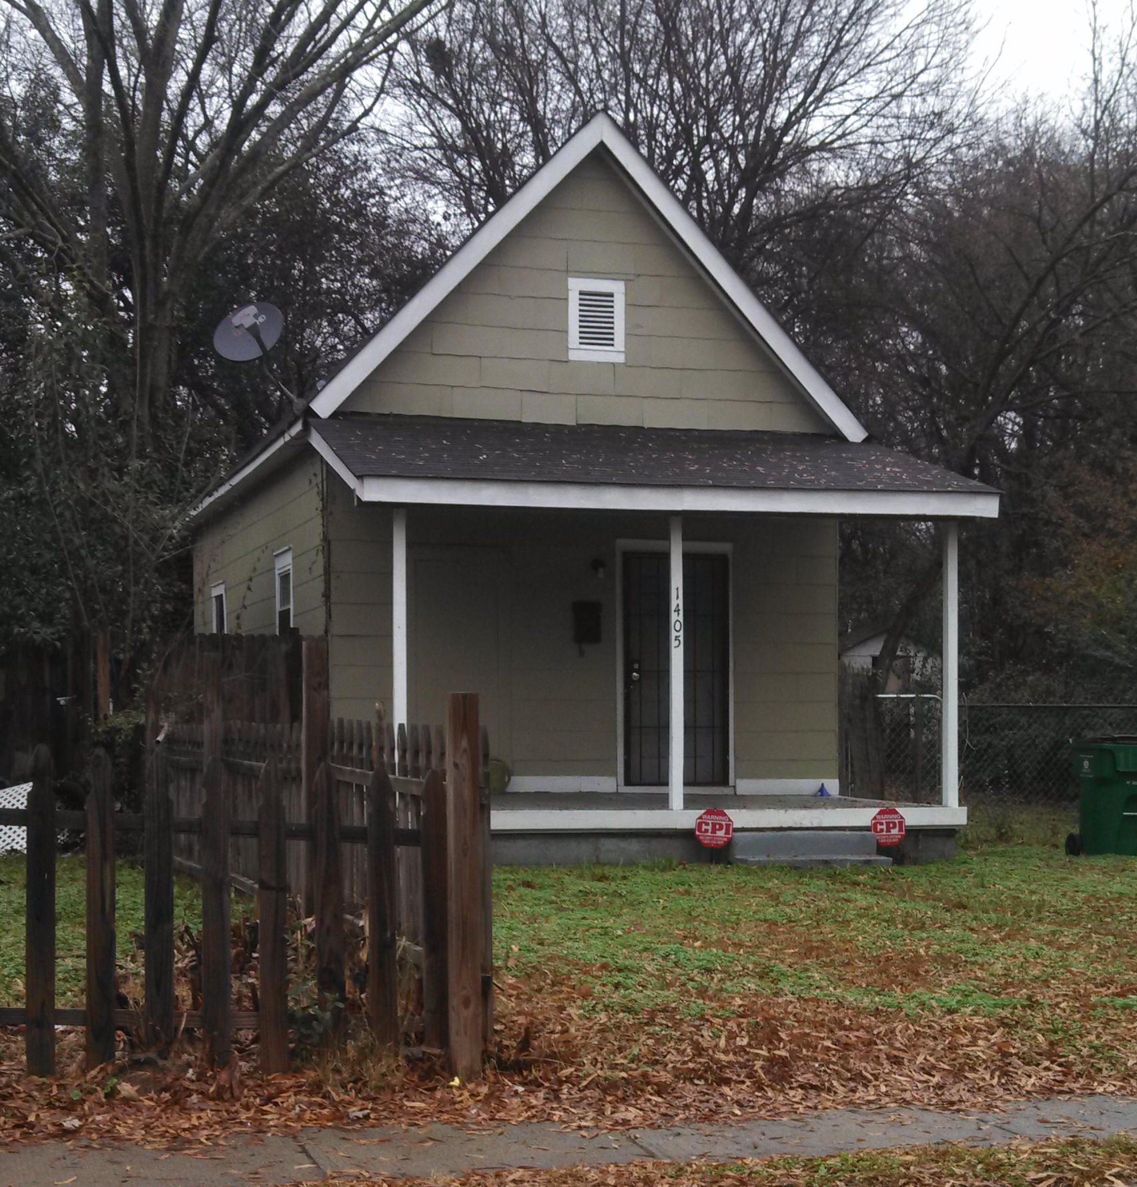
Belmont Shotgun House, 1405 Kennan Street, Charlotte
The Survey Committee presents a seconded motion to The Historic Landmarks Commission that the Belmont Shotgun House, 1405 Kennan Street, Charlotte, N.C., be placed on the study list of prospective historic landmarks.

Wilson, North Carolina
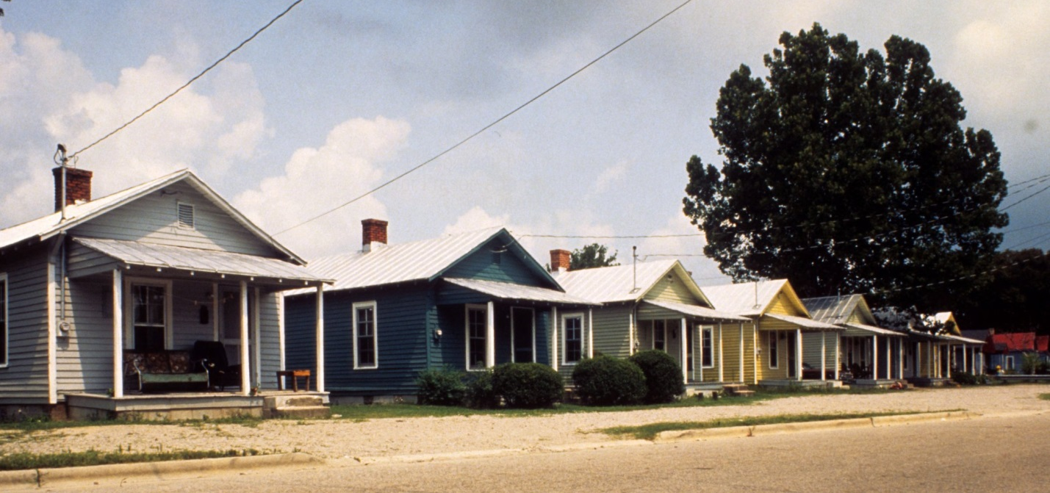
View, Vick Street houses,
Tim Buchman Photographs, 1988-1998
http://d.lib.ncsu.edu/collections/catalog/buch0657

Winston-Salem, North Carolina
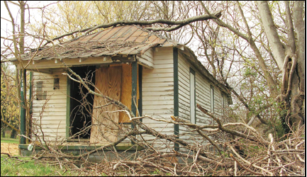
Above: The house at 716 Humphrey Street.
City wants new life for shotgun houses
June 05, 2014. The city is seeking developers to restore the two surviving shotgun houses in the historic Happy Hill community.
Long vacant, the houses – both on Humphrey Street and dating back to the early 20th Century – are owned by the city. Shotgun houses are immediately identifiable by their narrow rectangular form. Usually no more than 12-feet wide with rooms arranged behind one another, they got their name based on the theory that if a shotgun was fired through the front door, the bullet would pass unobstructed through the house and exit out of the backdoor. This type of historic African American architecture is believed to have its roots in West Africa.
Michelle McCullough, a Historic Resources Coordinator who is coordinating the project, said the city doesn’t have the funds to renovate the houses, so it is turning to the community.
“We’re looking for something creative. We’re looking for someone to use this historic building type and be creative and … put some love on them and really bring them back and see what they can use them for,” said McCullough, whose duties also include the historic marker program and staffing the Forsyth
County Historic Resource Commission.
Tomorrow is the deadline for interested parties to submit proposals for the units. The houses can be rehabbed on site or even moved to a similar neighborhood if necessary. The units don’t have to be refurbished for residential uses, necessarily. McCullough said she has heard of plans to convert old shotgun houses into coffeehouses, museums and a community gathering place.
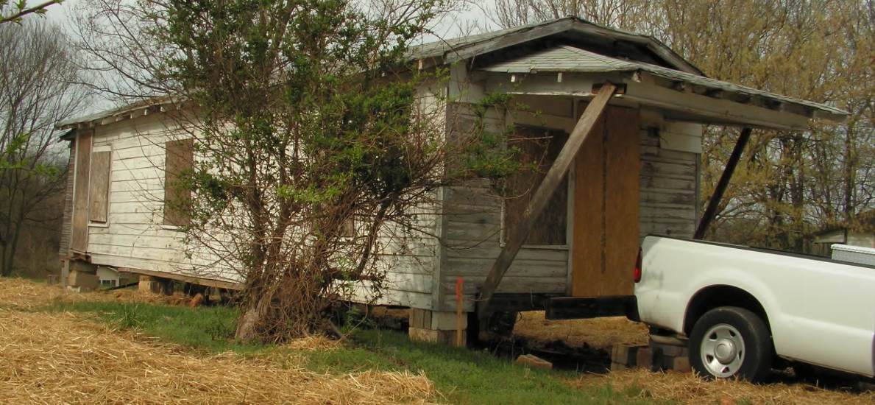
The 720 Humphrey Street unit.
The house at 716 Humphrey St. still sits on its original foundation and was acquired by the City in 2006. The other – at 720 Humphrey St. – used to sit on Alder Street and had been previously relocated before the city placed it near the other house earlier this year.
Several years ago, the now defunct Southside CDC had plans to turn the shotgun houses into residential units. State Rep. Evelyn Terry, who was the executive director of the CDC, said the proposed project had many plans and many false starts over the years but ultimately partners could not be secured to fund the restoration. She is hoping that the current initiative fares better.
“The reality about our history is why it’s so important (that) if you can preserve them, do such, said Terry. “… It’s a part of who we were, who we are.”
Edith Jones is a proud product of Happy Hill – the city’s oldest black community – and had been a part of past efforts to restore the shotgun houses. If the city’s effort does come to pass, Jones said she doesn’t believe any former residents of the community’s shotgun houses are still alive to see it.
Triad Cultural Arts, a nonprofit headed by Cheryl Harry, is among those submitting proposals. She is working in conjunction with Old Salem Museum & Gardens, Simon Green Atkins CDC, New Frontier CDC, architect David Gall and local art advocates Belinda Tate and Dara Silver.
Early this week, she declined to go into detail about the partners’ plans, as their proposal had yet to be submitted. She did say that the goal is to preserve the houses and seek the community’s help in doing so.
“We don’t want to lose any more structures that can speak to African American history; there just aren’t that many buildings or facilities still standing,” she said. “ So the more we can preserve, the more we can tell the story of the African American experience as it relates to Winston-Salem.”
http://www.wschronicle.com/2014/06/city-wants-new-life-for-shotgun-houses/
Chapter 4 Home Sweet Home
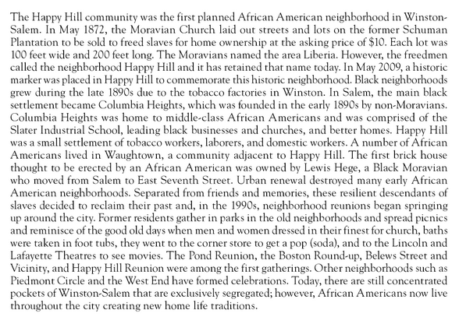
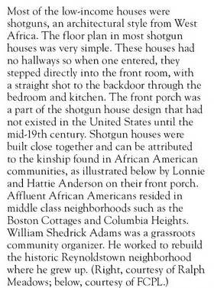
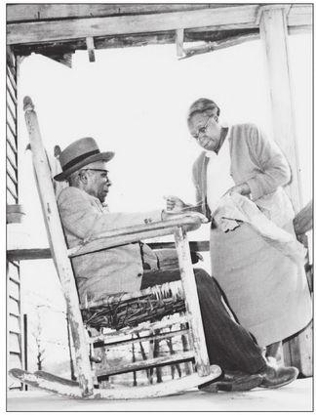
From: “Images of America, Winston-Salem’s African American Legacy” by Cheryl Streeter Harry, Arcadia Publishing, Charlotte, South Carolina, 2012.

