New York

Brooklyn, New York 3
Hyde Park, , New York 4

Brooklyn, New York

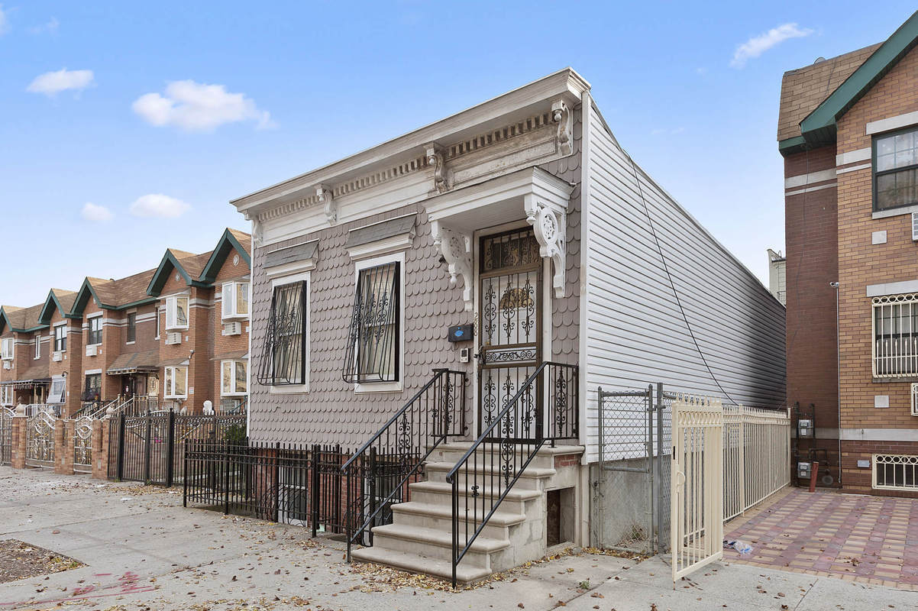
Stubby Shotgun-Style House Asks $775K in East Bed-Stuy
Bedford-Stuyvesant, Brooklyn is a neighborhood that’s famed for its architecture: majestic Italianate, Neo-Grec, Romanesque Revival and Queen Anne townhouses, churches and schools line a majority of the side streets. But this little house, at 288 Chauncey Street in East Bed-Stuy, stands in a category all its own. It looks more “New Orleans shotgun house” than Brooklyn townhouse, although it does boast a classic, historic cornice. It’s also rare to see a townhouse in the neighborhood that’s so stubby, with a one-story front facade (The home is actually a compact two-story, but the lower level sits mostly underground). What’s even the proper price tag for such an oddball home? A few years ago, it was asking $350,000, but now that the Bed-Stuy market is so hot it’s aiming high with an ask of $775,000.
The interior takes up a total of 1,580 square feet over both floors. Upon entering, you’ve got a living room with an open kitchen and dining room right behind it. There’s also a bathroom on this floor. And while the exterior is sure unique, the interior renovation is pretty bland–just your basic wood floors and white walls. At least it looks like you’re getting nice, high ceilings on this first floor. We’re so curious to know how the interior looked when this tiny house was first built!
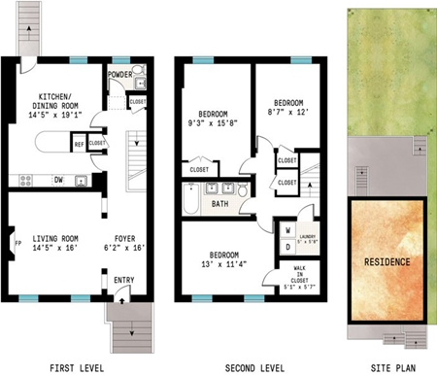
http://www.6sqft.com/stubby-shotgun-style-house-asks-775k-in-east-bed-stuy/

Hyde Park, , New York
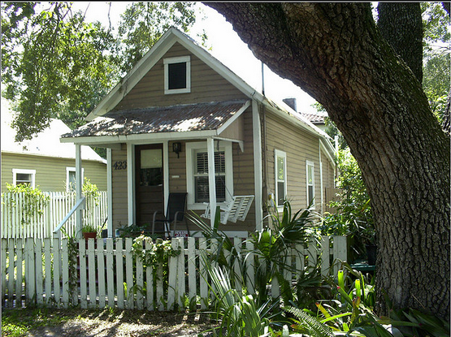
Vintage shotgun house in Hyde Park

https://www.flickr.com/photos/flarchfan/2757637857/in/photostream/

