Nevada

Ely, Nevada 3

Ely, Nevada
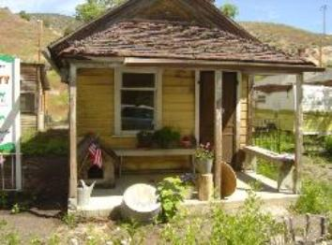

In 1999 the Ely Renaissance Society purchased “a piece of property made up of 12 shotgun houses and a barn”. These small houses have been made into unique museums depicting the turn of the century population of Ely and the history of the ethnic groups that worked for the railroad and mines (copper beginning in 1906, then gold).
http://www.elynevada.net/thingstodo/Historical/renaissance.html

In 1907 the following excerpt appeared in the White Pine News:
HOUSES FOR RAILROAD MEN
Six dwellings going up at Eighth Street and Avenue B in Ely City which will be occupied by railroad men employed by the Nevada Northern about the yards, most of whom are married and anxious to bring their families. Other houses will be erected as the force of railroad workers is increased.
Renaissance Village Beginnings, By Betty Orr
It was first assumed that the five matching houses here at the Renaissance Village were section houses, placed along the line for the Nevada Northern section bosses. But further research revealed that section houses were of a different dimension being
rectangular in shape. (The railroad houses here measure 24 x 24 feet.) Bill Geraghty bought the railroad houses and moved them to their present site in the early 20’s. Originally there were six matching houses but one had been sold when Geraghty bought the remaining five. These had been built at 8th and B Street in East Ely in 1907 to house railroad yard workers. A sixth house was substituted and it is slightly larger and has a different floor plan. This is now used as an artist studio. Insurance papers recently discovered have diagrams of the Railroad houses and their placement on the property.

