Missouri

Columbia, Missouri, Boone Junction History Village 3
St. Louis, Missouri 4
St. Louis, Missouri, Marshall School Neighborhood in The Ville Historic District 6

Columbia, Missouri, Boone Junction History Village
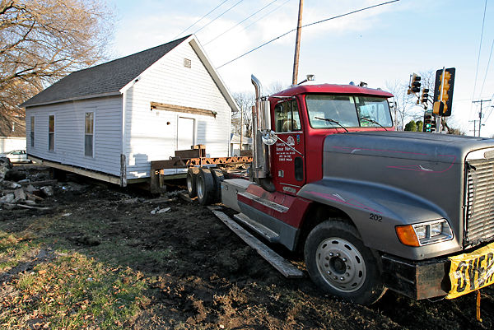
Update: Shotgun house makes cross-town move to Boone Junction History Village
This shotgun house has been standing since the 1920s and was the first notable historic property in Columbia, said Mike Martin, one of its owners. He and Brian Treece, the other owner of the property, bought the house in 2007 and have been discussing its relocation with the Boone County Historical Society and City Council for many months.
Workers labored for two days to get the house off the ground, Treece said. They installed cribbing to stabilize the structure and then jacked it up so they could push a trailer underneath it. A special foundation was laid at the History Village so the house could be backed in and lowered to the ground.
Dozens of neighbors gathered in the cold to watch the progress of the house as workers from utility companies hurried to move telephone and electric lines out of the way.
Across the street, Samantha and Kelly Vanengelenhoven watched from their house. “It’s sad to see it move, but it’s better than tearing it down,” Samantha said.
By Laura Li, March 12, 2009, Missourian

St. Louis, Missouri
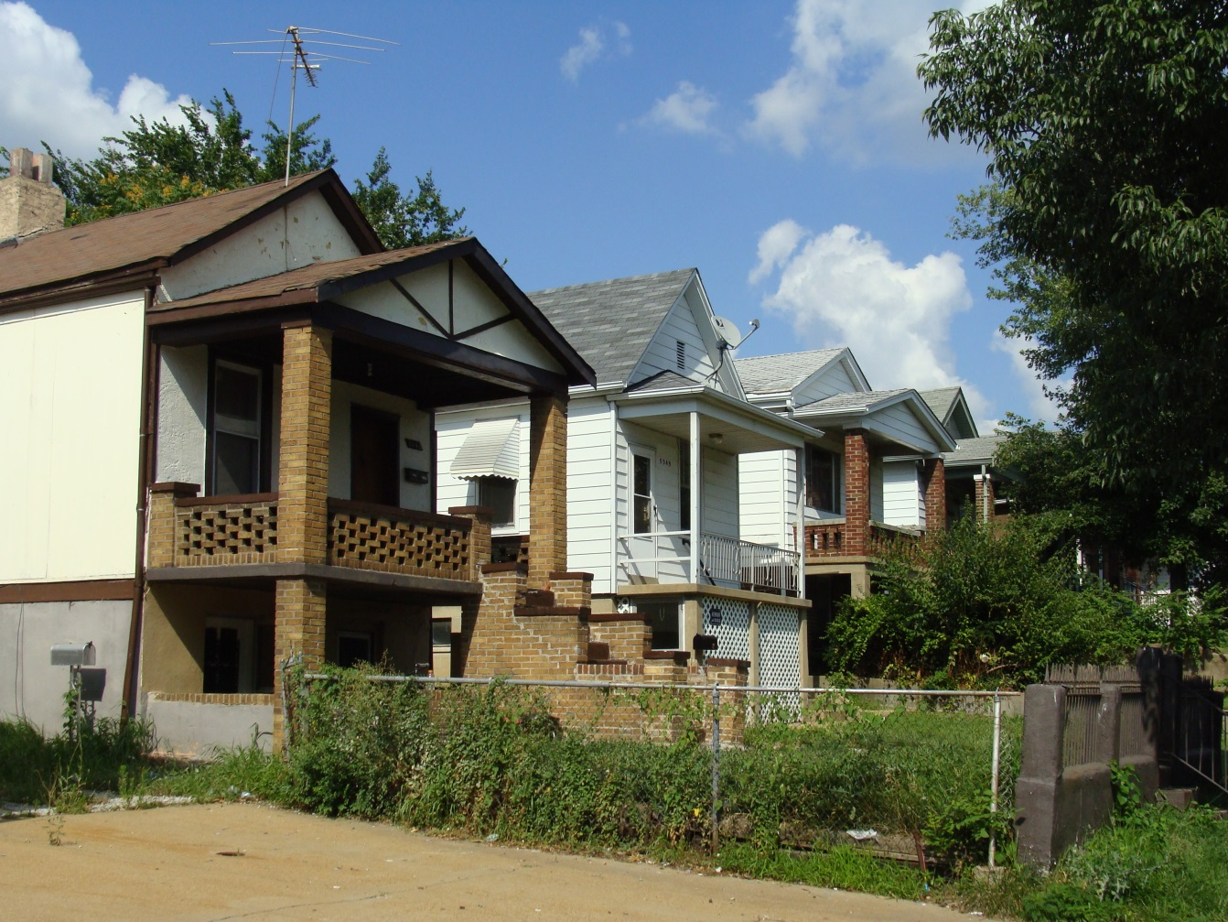
The site of clay mines and the accompanying brick industry, The Hill is famous for being the center of Italian-American culture in St. Louis. While there are few mansions on The Hill, there is street after street of tidy shotgun houses interspersed with the iconic St. Ambrose Catholic Church and numerous famous restaurants. The Hill never declined like other parts of the city, and a stroll through the area can give the visitor an idea what dozens of other St. Louis neighborhoods were once like in their prime. http://stlouispatina.com/south-st-louis/
The shotgun house is often found in older St. Louis neighborhoods. This vernacular building type is probably a Caribbean house form that was brought to the American south in the 18th century by Caribbean traders and slaves. The building type proliferated throughout the south, especially in New Orleans, and settlers brought the type north through the Mississippi valley. Shotgun houses are single-story buildings with narrow front facades. There is no interior hallway: each room leads directly into the one behind it. Shotgun houses appear in frame with a front-facing gable, or in brick, with a hipped roof. Examples from this period can be found in Carondelet, Hyde Park and Old North St. Louis neighborhoods. The shotgun house at 8225 Vulcan, in Carondelet, is built of brick on a rubble stone foundation. Constructed about 1860, it is three rooms deep and has a low hipped roof, and simple corbelled cornice. https://www.stlouis-mo.gov/government/departments/planning/cultural-resources/preservation-plan/Part-II-The-Walking-City-Rural-House-Forms.cfm
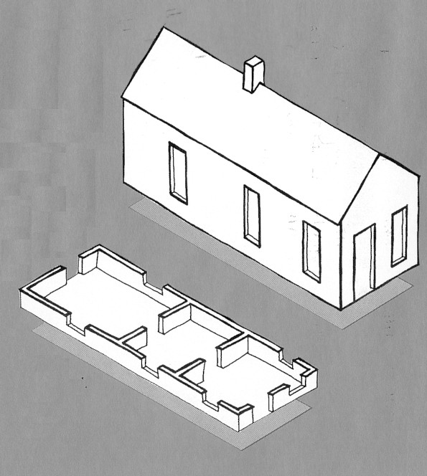
While its ultimate origins are debated by scholars, some researchers believe the shotgun house type is a dwelling form with African and Caribbean roots. Shotgun houses were often built by African-Americans, but this functional, practical house form (well suited to narrow urban lots) was also built and used by white people. The house type may reflect a practical African vernacular dwelling carried in people’s memories up the Mississippi River to Missouri by 19th century slaves/builders with cultural roots in West Africa and the Caribbean islands. Great numbers of shotgun houses were built in the larger towns and cities, particularly those along the major rivers and railroad centers of the South and lower Midwest such as New Orleans, Memphis St. Louis and Louisville.
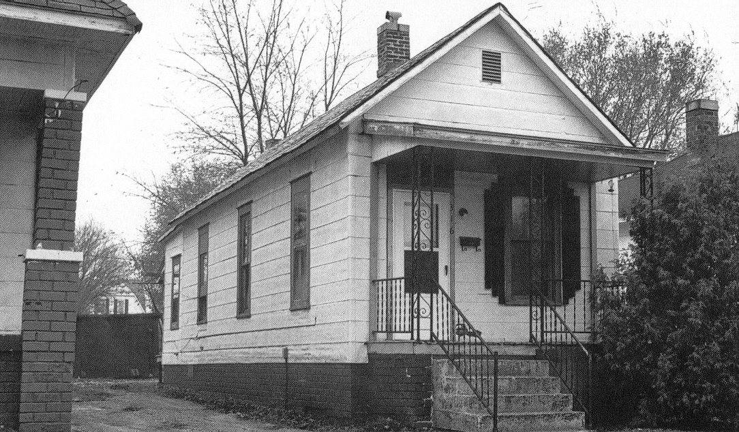
Unfortunately, many people have come to view these modest houses as a reflection of poverty or a reminder of racial conflict, especially when they are located in African-American neighborhoods. The shotgun house is a type of vernacular building that calls for documentation and analysis by future researchers so that Missouri’s complicated multicultural heritage can be better understood.
Vernacular Architecture in Rural and Small Town Missouri: An Introduction
Howard Wight Marshall Copyright 1994, Curators of the University of Missouri
http://missourifolkloresociety.truman.edu/marshall.html

St. Louis, Missouri, Marshall School Neighborhood in The Ville Historic District

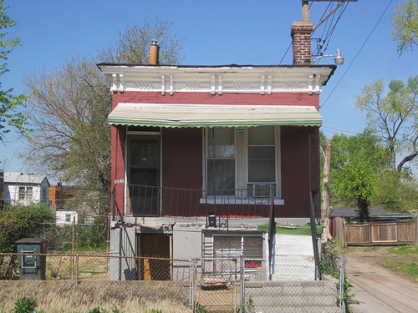
The district includes six one-story shotgun houses with Italianate details on Billups Avenue. This house is at 1713 Billups Avenue. It dates to 1892 and was built by H. Feuerbach.

http://preservationresearch.com/projects/the-ville-historic-districts/

