Kentucky

Covington, Kentucky 3
Davis Bottom, Kentucky 5
Louisville, Kentucky 6
Louisville, Kentucky, Thomas Edison House 7

Covington, Kentucky
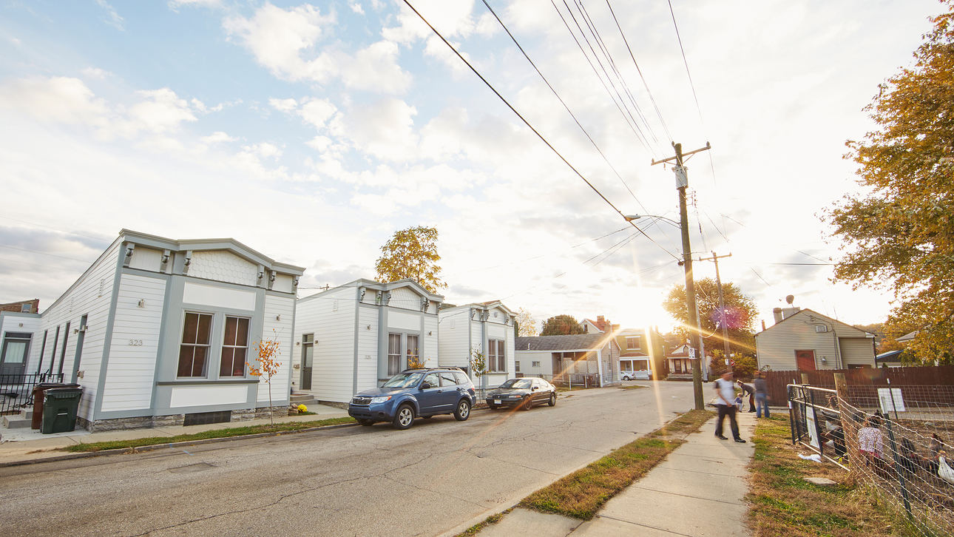
West Side Story: Covington's Shotgun Houses
A row of rehabbed shotgun houses in Covington, Kentucky, fosters a sense of community.
Six homes are now touted by Covington city planners as Shotgun Row. Five have been completely rehabilitated by the nonprofit Center for Great Neighborhoods with gingerbread cornices restored; new cement-board siding painted a cheery white; and interiors modernized, some with hardwood floors, granite countertops, and dangling halogen lamps.
The Center was founded as a community services group back in the 1970s, but since 2006 part of the organization’s mission has been to acquire, rehabilitate, and sell derelict or seriously dilapidated historic buildings on the west side of Covington, a working-class enclave across the Ohio River from Cincinnati. The idea is that when these old properties are fixed up, public safety improves, the housing market stabilizes, and people feel optimistic about their neighborhoods. “It gives residents hope,” says Sarah Thompson Allan, program director for the Center. “These old buildings can have life in them, and restoring them can bring life into a community, as well.”
The Center has completed more than 30 pro-jects in Covington in recent years, but Shotgun Row, for which it received a state historic preservation award, might be its crown jewel. “These houses were so far gone, people questioned why we would even want to save them,” says Allan, who spearheaded the development. “But with this project we were leveraging so much more than just a single building. We basically took the worst block and helped transform it. People look at Shotgun Row now and don’t even see the [individual] houses. It’s like its own beautiful entity. It was definitely the most transformative project we’ve ever done.”
It was sometime around 1890 that Henry G. Haver, a foreman at the local wire works, bought a parcel of land along Orchard Street and built seven shotgun-style homes, one room wide by three or four rooms deep. (One of the houses burned down in the 1990s.) They were more ornate than the typical shotgun, with basements, high ceilings, Italianate cornices, and two tall windows on the street-facing side. Haver moved his family into one and sold the others, likely to laborers either at the wire works or at the nearby lumber mill, rope works, or Bavarian brewery.
At the time, Covington was the industrial hub of Northern Kentucky, and it remained that way until the economy collapsed during the Great Depression. During the ensuing years, migrants from Appalachia flooded the city looking for work that often wasn’t there, and during the next several decades many of the city’s grand homes were divided into apartments. By the 1960s and ’70s, urban flight left many buildings vacant, particularly in the city’s Westside neighborhood. Crime skyrocketed, and during the mid-2000s, the police were averaging almost 1,500 calls for service to the neighborhood every year. Orchard Street, which was the scene of two murders in 2004, was practically its epicenter. But the block was part of the Lee-Holman Historic District—one of 17 protected areas in Covington—and had its share of historic structures, including Haver’s unique row of shotgun homes.
It was the longest row of shotguns in the entire city—something worth preserving. The project’s success proves there’s a market for the oft-maligned shotgun house, a narrow, linear design that hasn’t been in favor since the Hoover administration. (Some believe the name originated from the fact that a bullet fired from a shotgun could travel straight through the house from front to back, while others attribute it to the evolution of the African term “to-gun,” which means “place of assembly.”) “Our hope is that shotguns can be repurposed in a way that they become an option for people who want to age in place,” says Allan. She notes that the one-floor structures are also perfect for people who, like two of Shotgun Row’s current residents, have mobility challenges.

Excerpts from: Preservation Magazine, Spring 2016; article by Joe Sugarman; photos by Aaron M. Conway

Davis Bottom, Kentucky
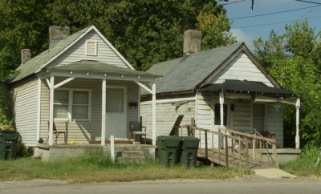
Two shotgun houses at 710 and 712 DeRoode Street, 2010

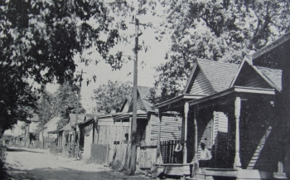
Shotgun homes in an African American community (unidentified) published in A Comprehensive Plan of Lexington, 1931. Courtesy, Lexington Public Library.
Many of the residential homes built in Davis Bottom were an architectural style commonly known as the “shotgun” house. This single-story, wood-frame home was built throughout the Southern United States from the 1860s to the 1920s. Shotgun homes are inexpensive, rectangular structures designed to fit narrow lots on urban streets. From Kentucky Archeological Survey.

Louisville, Kentucky
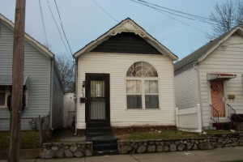
A typical shotgun house in Louisville can house a family of five or six comfortably and cooled cheaply using a combination of open windows on all four sides and fans; changing the width size of neighborhoods zoned for shotguns will increase the price of housing keeping out the original residents.
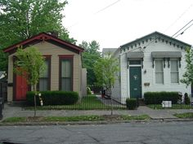
Pair of shotgun houses, Old Louisville.

Louisville, Kentucky, Thomas Edison House
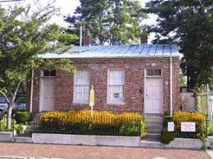
Thomas Edison House
Just after the Civil War, a 19-year old Thomas Edison is thought to have rented a room in this building during part of the 1 1/2 years he worked in Louisville, Kentucky, as a telegrapher for Western Union. Built in the 1850s, the structure is one of the few remaining shotgun duplexes in the area.
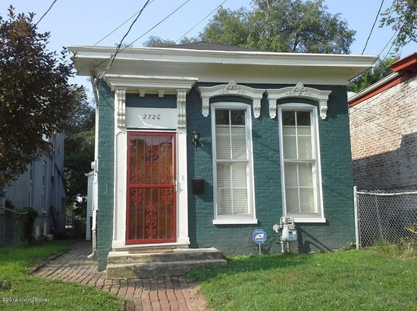
Brick Shotgun House, Louisville, Kentucky.

While shotgun houses are traditionally of frame construction, Louisville has hundreds if not thousands of shotgun houses constructed from brick.

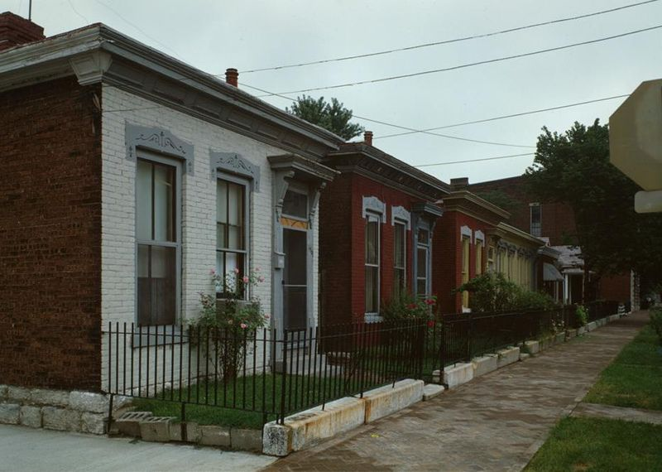
Shotgun houses spaced tightly together in Louisville, Kentucky. In cities, shotguns were built close together for a variety of reasons.
"Shotgun houses – slight cropped". Licensed under Public Domain via Commons - https://commons.wikimedia.org/wiki/File:Shotgun_houses_%E2%80%93_slight_cropped.jpg#/media/File:Shotgun_houses_%E2%80%93_slight_cropped.jpg

https://en.wikipedia.org/wiki/Shotgun_house

