Kansas

El Dorado, Kansas, Kansas Oil Museum 3
Kansas City, Kansas, Strawberry Hill Neighborhood 4

El Dorado, Kansas, Kansas Oil Museum
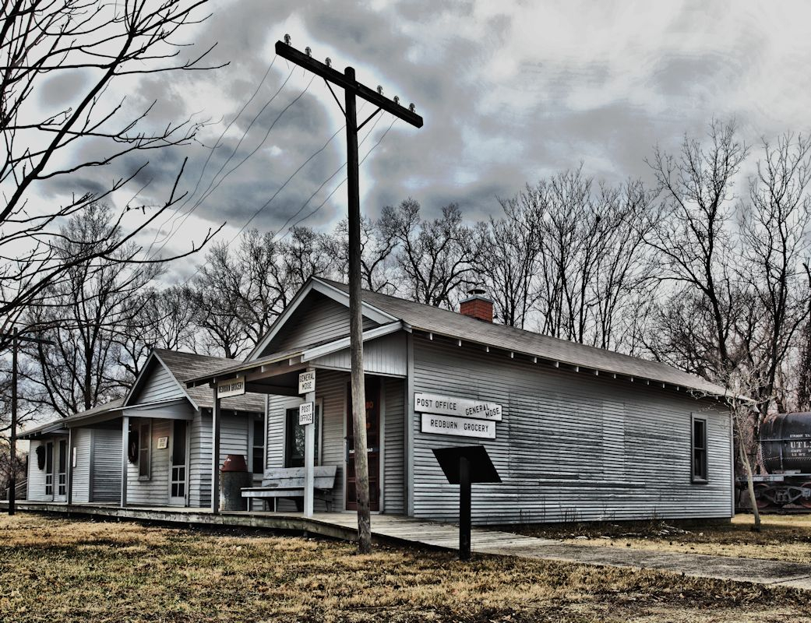

History is preserved at the Butler County History Center / Kansas Oil Museum, 383 E. Central in El Dorado.

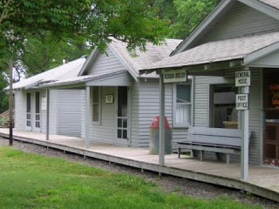
At the Kansas Oil Museum one may step back in time and relive this period of oil exploration in Butler County. A visitor can tour a pump house and two styles of operational drilling rigs, as well as a shotgun style house from Oil Hill. At this former site of Oil Hill boomtown, imagine 2,500 workers living here in shotgun houses.

For more info see Kansas Sampler Foundation and Kansas Oil Museum

Kansas City, Kansas, Strawberry Hill Neighborhood
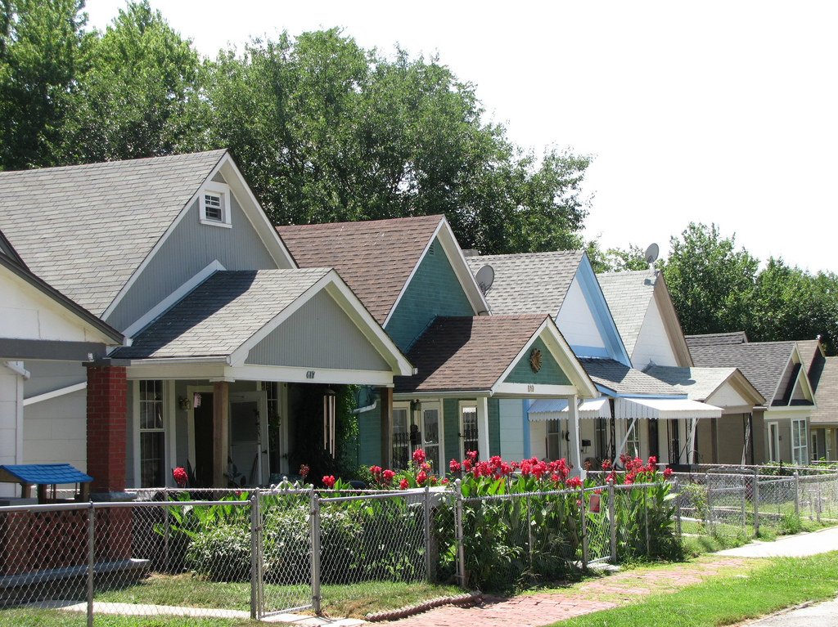
Strawberry Hill Shotgun Houses

Originally known as Splitlog’s Hill, Strawberry Hill is adjacent to the south of downtown Kansas City, Kansas. Historically extending east down the slope to the banks of the Kansas River, more than 200 parcels along the east side of the neighborhood were cleared in the late 1950s to make way for the Muncie Expressway (present-day I-70).

Thompson Street Shotgun District, a small collection of five shotgun houses at 411-419 Thompson Street built
around 1885 as a set by a single developer believed to be Peter Larson.

https://www.flickr.com/photos/jimsawthat/12113799576

