Illinois

Ashmore, Illinois 3
Cairo, Illinois 4
Springfield, Illinois 5

Ashmore, Illinois
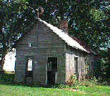

This shotgun house, built during the 1920s, is located in downtown Ashmore. Although it is in a state of deterioration, it reveals some of the basic characteristics of a shotgun house. A shotgun house is one room wide and two or more deep, with a front-facing gable. The history of the shotgun house is quite complex. It originated in Louisiana among the free black communities in early America and the design was based on African and Caribbean influences. The shotgun house supposedly received its name from the fact that you can open the front and back doors and fire straight through with a shotgun.
From Residential Architecture, Coles County, Illinois
http://www.eiu.edu/localite/archhome.php

Cairo, Illinois
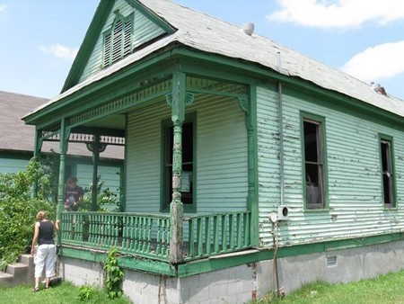
Aiming for a Better Future: Volunteers to Help Restore Shotgun Houses in Southern Illinois
Once General Grant's Civil War headquarters, Cairo was also an economic and cultural hub known for steamboats and blues musicians. In the 1960s, it saw intense civil rights activity. Its architecture reflects this storied past and includes an impressive array of shotgun houses.
One goal is to increase the stock of affordable housing by restoring abandoned homes, many of which are eligible for inclusion on the National Register of Historic Places. Historic preservation is also a key way to increase tourism and to bolster community spirit. HCN’s shotgun project is a critical component of the affordable housing initiative.
For more information, visit HCN’s website, http://www.heritageconservation.net/ws-cairo.htm, or call +1 303 444 0128.

Springfield, Illinois
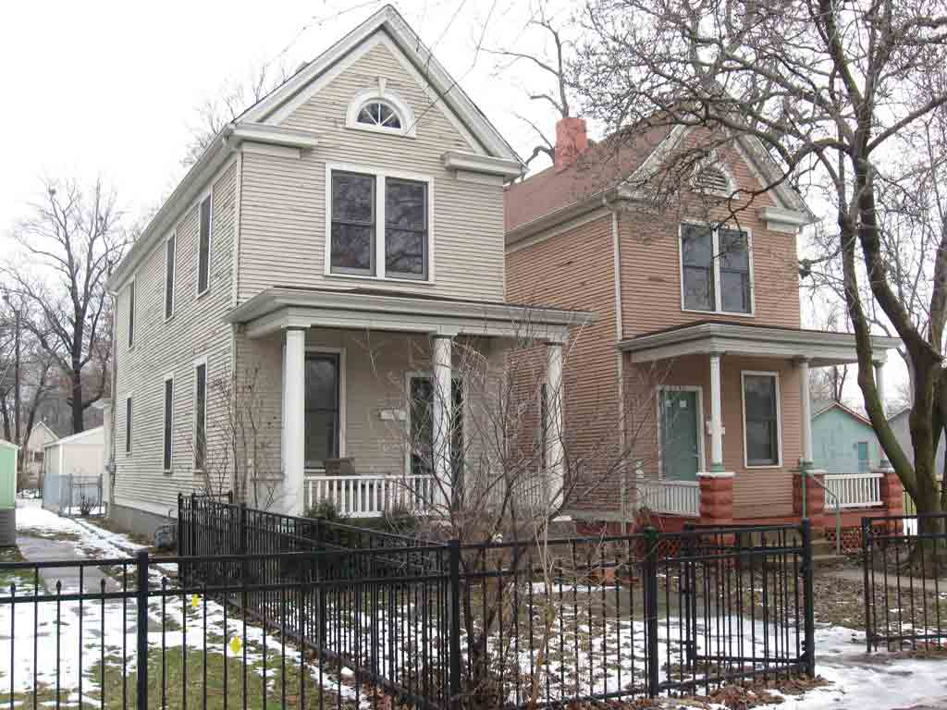
1100 Block of N. 5th St. This row of shotgun houses is on the west side.

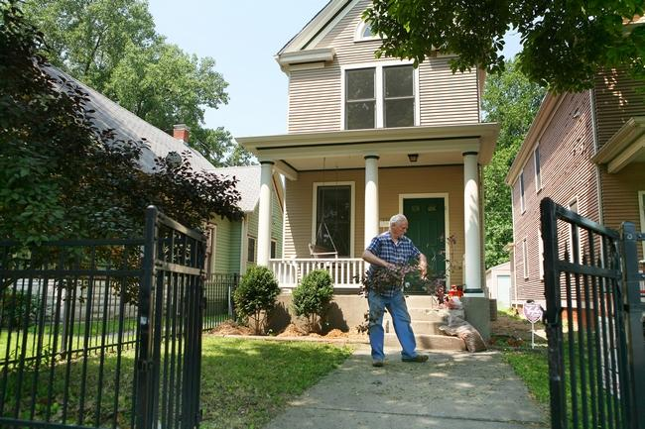
The two-bedroom, 1.5-bath home at 1129 N. Fifth St. dates back to 1909 and is a “shotgun house.” The front and back doors line up so if a shotgun was fired in the front door it could exit through the back.

