Georgia

Atlanta, Georgia; Auburn Avenue 3
Atlanta, Georgia; Martin Luther King Birth Place Neighborhood 5
Macon, Georgia, Little Richard’s Birthplace 7
Macon, Georgia, Home of Otis Redding 8
Wayne County, Georgia 9

Atlanta, Georgia; Auburn Avenue
Shotgun Houses are long and narrow homes, often in a row, that catch your eye for their unique and endearing shape. The shotgun house is often no more than 12 feet wide, with 3-5 rooms set in a row without a hallway. This lack of a hallway allows for excellent airflow and cross ventilation throughout the home, which is a must for the hot southern summers, particularly before the invention of air conditioning. You'll often find that shotgun homes were built close or even flush with the sidewalk. There is a single door and window at the front of the home and a side door towards the back that leads to the final room. And there's always just enough room for two rocking chairs on the ever important front porch...

First popularized in Orleans, the shotgun house was once the most sought after home in the South from the 1860's-1920's. Although many today have cement stairs, the original shotguns all had wooden steps. The homes are traditionally built 2-3 feet off the ground, a sure indication of their New Orleans heritage.

As manufacturing jobs become more plentiful in the cities during the late 1800's and early 1900's, these homes were built to accommodate the influx of new workers.

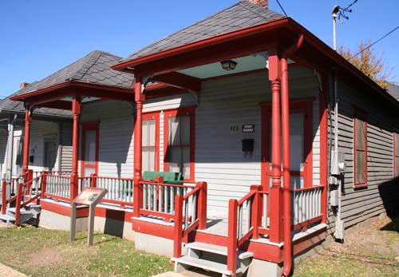
Often, several would be built in a row by the same builder, which lent to their similar appearance. On historic Auburn Avenue in Atlanta, you'll see the preserved row of Double Shotgun homes or two shotgun homes joined together, sharing a central wall. As a sign posted outside the homes explains, "These duplexes are typical of the houses where Atlanta's blue-collar laborers lived in the early 1900's. The Empire Textile Co. built them for its white mill workers, but they moved out after the 1906 race riot, and blacks began renting them."

The best areas in the South to still see shotgun homes are at Bywater in New Orleans, Cabbagetown in Atlanta, or Portland, Butchertown and Germantown in Louisville.

From: http://www.sweetpeachblog.com/journal/2011/11/9/the-shotgun-house.html

Atlanta, Georgia; Martin Luther King Birth Place Neighborhood

Excerpt, Chapter One, The Development of a Black Community and Leader: Atlanta's Auburn Avenue Neighborhood and Martin Luther King, Jr., 1906-1948

Two-story Victorian houses, two-room shotgun cottages, and boarding houses shared Auburn Avenue addresses.
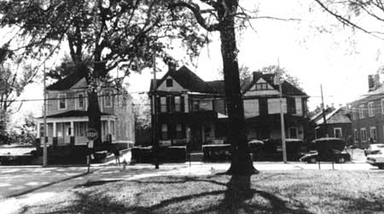
Photograph 2: Two-story residences on Auburn Avenue with shotgun houses behind.

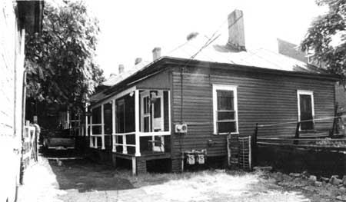
Photograph 3: Two-room double shotgun houses on alley leading from Auburn Avenue.
Excerpt, Chapter Three, Architectural Resources of the Martin Luther King, Jr., National Historic Site, Ca. 1880-1950
Multiple-Family Residences
Appearing in New Orleans as early as the 1830s, the shotgun house was diffused throughout the South, at first along river trade routes and later in other areas. The type's greatest popularity came between 1880 and 1920, when it was a common choice for mill housing and for speculative developments marketed to working-class whites and blacks. The origins of the type have been debated by historians, some of whom have argued that slaves brought the type from West Africa to Haiti and then to New Orleans. Others have suggested that it originated when the traditional hall and parlor plan was turned sideways to accommodate narrow urban lots. [112]
The defining characteristic of the shotgun type is a plan one room wide and two or three rooms deep. The name derives from this arrangement of rooms opening directly into one another. A shotgun blast fired through the front door supposedly would travel through the house and exit at the back without hitting a wall. The long, narrow configuration of the house made the type a good fit for narrow-frontage urban lots. Shotguns are one-story houses with a door and window on the front elevation and a hip or gable roof. Shotguns commonly exhibit engaged or attached front porches, typically gabled or shed. The chimneys are usually central. Many shotguns lack stylistic features, since they are utilitarian in nature, but some examples incorporate decorative millwork.
The double shotgun house is a four-bay, duplex version consisting of two shotgun-plan flats under one roof, joined by a party wall with separate front entrances for each half of the house. The porches, chimney placement, and entry location vary among double shotguns, which first appeared in New Orleans around 1850 and spread throughout the South. [113]
In 1905, the Empire State Investment Company purchased the western portion of the block bounded by Auburn Avenue, Boulevard, and Old Wheat Street and constructed nine double shotgun houses there (photograph 16). Built as speculative rental housing for whites, the double shotguns were all black-occupied by 1910. [114] As built, these double shotguns had hipped roofs, weatherboard siding, and hipped front porches for each unit. Ornament was limited to turned posts and sawn brackets on the porches.
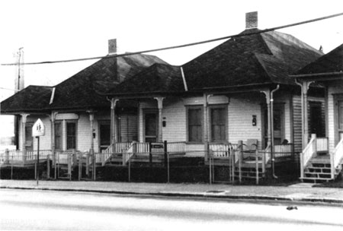

Photograph 16: Double shotgun houses at 472-474 and 476-478 Auburn Avenue.

Macon, Georgia, Little Richard’s Birthplace
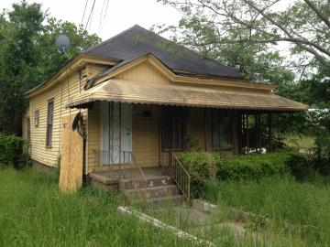
Musician "Little" Richard Penniman grew up in this late-Victorian shotgun house in Macon's Pleasant Hill neighborhood. It’s not tiny, but it’s awfully hard to imagine the young Penniman living there in the 1930s and '40s with his parents and 11 siblings. (Photo: Adam Ragusea/GPB News)

The Richard Penniman Resource House

Penniman said he had heard about the state acquiring his boyhood home. I asked what he remembered about it.

“All I remember is that it was an old house, with a bathroom toilet stool in the hallway,” he said. (A toilet stool is a chamber pot set in a chair — evidently the house had no indoor plumbing.)

“I had some good meals there,” he continued, “and had a good mama there, my mama she was a good lady. And they’re getting ready now to make [the house] for everybody, for the young people.”

From: Little Richard Gets Hometown Honors, by Adam Ragusea, May 12, 2013
http://www.gpb.org/news/2013/05/12/little-richard-gets-hometown-honors

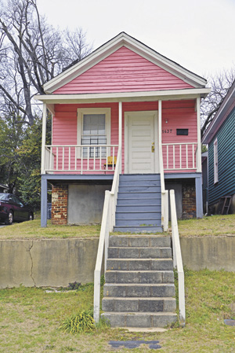
Little Richard spent part of his childhood in this pink shotgun house in Macon’s Pleasant Hill neighborhood.
http://www.vieravoice.com/Senior-Life/July-2015/Makin-music-in-Macon/

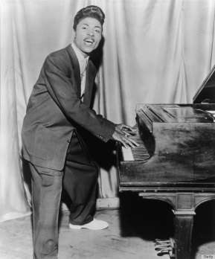

Left, Little Richard, circa 1957; Right, Little Richard retires from Show Biz at 80, September 3, 2013

Macon, Georgia, Home of Otis Redding

Otis Redding was born on September 9, 1941 in Dawson, Georgia, one of Otis Redding Sr. ’s six children. At age three Redding moved with his family three hundred miles north to Macon, and settled into the Belleview housing project, known to local residents as Hellview. Not long after, Reddings’ father—a part-time preacher employed at nearby Robbins Air Force Base—moved the family into a small shotgun house. After fire damaged the residence, the family moved back into Macon’s housing projects. During his early years in Macon, Redding sang in a gospel group, played drums in the school band, and performed piano at local talent contests.

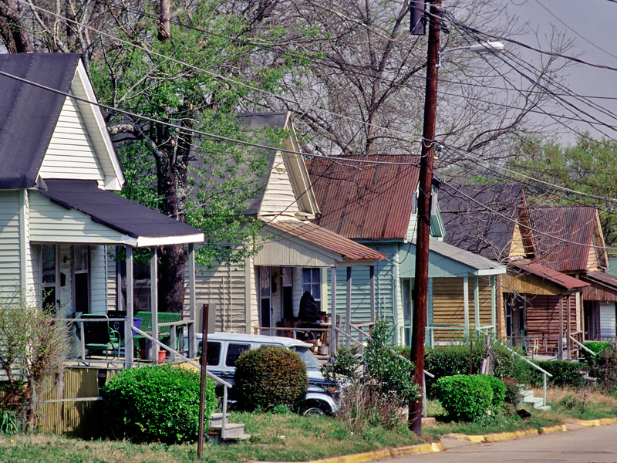
Unrestored shotgun houses line a street in Macon. The shotgun, a rectangular house type that is one room wide and two to four rooms deep, may have developed from a West African architectural tradition.
Courtesy of Elizabeth Lyon
http://www.georgiaencyclopedia.org/file/9188

Wayne County, Georgia
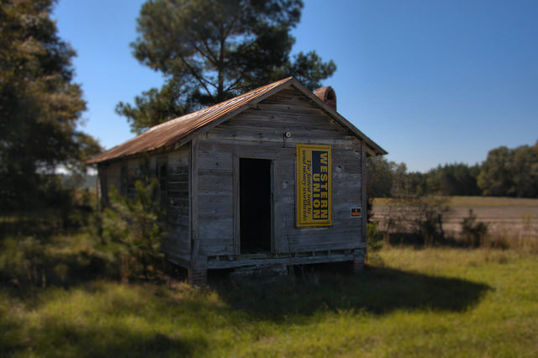
This is located on Holmesville Road in southwestern Wayne County and a contact suggested it may have been a country store. The more I look at it, though, it seems to have a lot of windows for a store. It could be an old shotgun house.
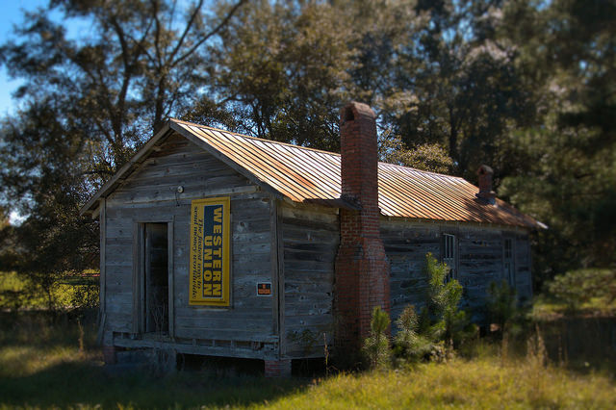
Referenced on pg. 23 of OLD HOUSE, NEW FUTURE: THE QUIET REVIVAL OF THE SHOTGUN HOUSE, By Belinda A. Tate, A Thesis Submitted to the Graduate Faculty of WAKE FOREST UNIVERSITY

