Florida

Apalachicola, Florida 3
Century, Florida 4
Fort Meade, Florida 4
Jacksonville, Florida 5
Key West, Florida 7
Mims, Florida 8
Pahokee, Florida 9
Pensacola, Florida 10
St. Augustine, Florida; Lincolnville Neighborhood 12
Sarasota, Florida; Overtown Community 13

Apalachicola, Florida

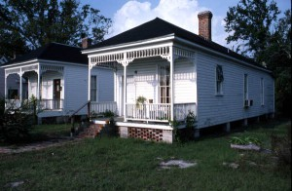
Image by David A. Taylor

American Vernacular Architecture: The Shotgun Style in Florida

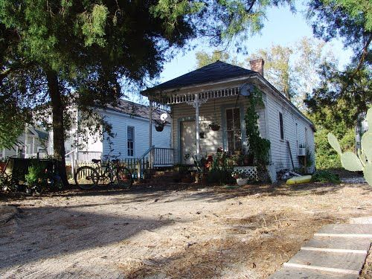

A true Victorian shotgun, historic Apalachicola Florida (11-26-2011)

Image by Donna Crews: https://www.pinterest.com/pin/157203843216510875/

Century, Florida
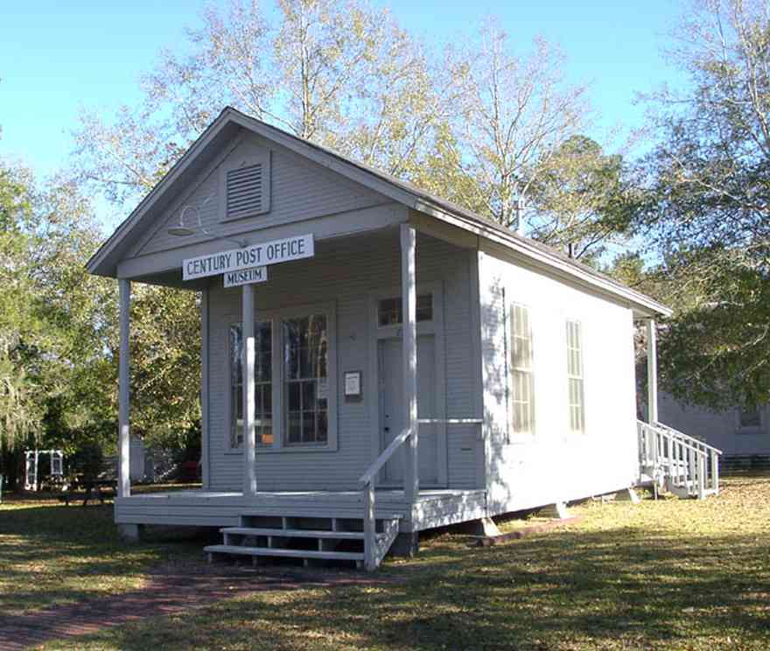
Century: Historic District: Post Office Museum
Century is a small town that flourished at the end of the 19th century. The major industry was the lumber business. The historic district features Victorian homes.

The shotgun house is a typical style and served as home for many lumber mill workers.

Fort Meade, Florida
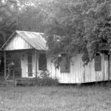
Shotgun-Shack,
American Vernacular Architecture: The Shotgun Style in Florida
http://preservation.myfloridahistory.org/american-vernacular-architecture-the-shotgun-style-in-florida/

Jacksonville, Florida
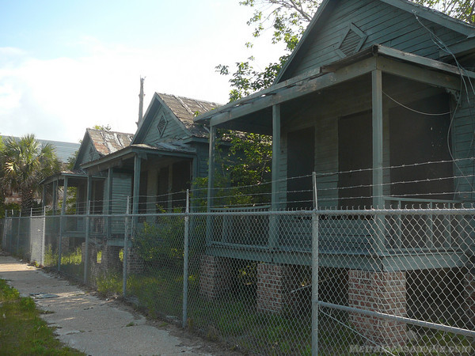
LaVilla Shotguns
Just south of Genovar's Hall, these three decaying shotgun homes were saved from the area's urban renewal demolition frenzy and relocated to this site.

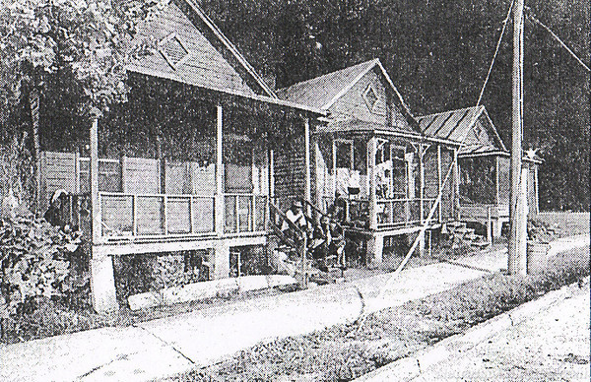

Constructed in 1914, they were originally located on the 600 block of Lee Street.

From Ashley Street: The Harlem of the South
Published May 13, 2009 in History - MetroJacksonville.com

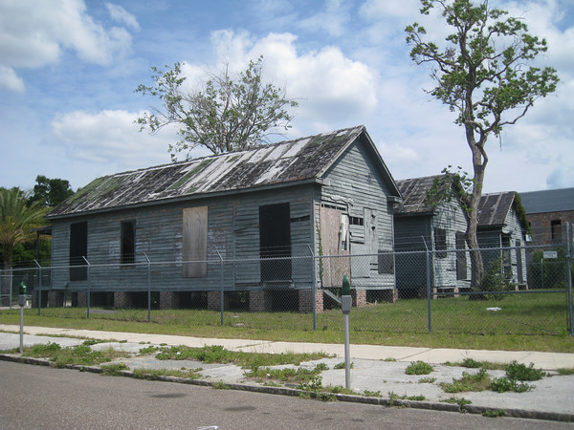
Rear view of the LaVilla Shotgun Houses. Built between 1890 and 1930, the LaVilla "Shotgun" houses are three survivors of a distinctive style stored for future restoration, yet rapidly deteriorating beyond economical repair. Working people lived in these practical one story homes in which one could shoot a shotgun straight down the long interior hallway and out the front door.
http://www.metrojacksonville.com/article/2012-may-jacksonville-historical-society-twelve-worth-saving

Key West, Florida

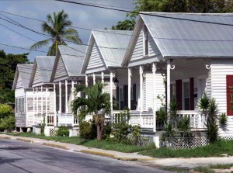
Image by Dale M. McDonald.

American Vernacular Architecture: The Shotgun Style in Florida
http://preservation.myfloridahistory.org/american-vernacular-architecture-the-shotgun-style-in-florida/

Built primarily in the rural southern regions of the United States including Florida, Louisiana, Texas, Mississippi, Alabama and Georgia from the late 1800s to the early 1900s, the Shotgun style is a one- or one-and-a-half-story house that is commonly supported on short piers, is typically one room wide and several rooms deep, with all rooms and their doors in a straight line perpendicular to the street. These homes are often built with a narrow gable front with a porch, often with a similar porch at the rear. (Reference: shotgun house. (2006). In Dictionary of Architecture and Construction. Retrieved from http://www.credoreference.com/entry/mhbuilding/shotgun_house)

There are several variations of this style, including the Double-barrel Shotgun, the Camelback, and the Double Width Shotgun. Double-barrel Shotguns are basically duplexes, or two separate Shotgun houses sharing a single, central wall to allow more houses to be built in an area. The Camelback is a Shotgun with a second story built onto the rear of the house. A Double Width Shotgun is a single structure that’s twice the width of a normal Shotgun. (Reference: http://www.casasugar.com/Architecture-Styles-Shotgun-House-1017383)

Mims, Florida
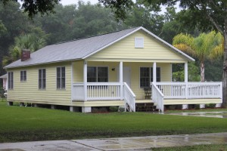
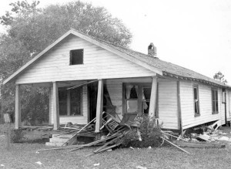
Double Width Shotgun, Restored Home of Harry & Harriette Moore (left); photo after 1951 bombing (right) Image on left by Lesa Lorusso, Image on right from State Archives of FL, FL Memory
Nestled on 12 acres of old orange groves in Mims, Florida stands an example of the uniquely African American Vernacular style. Located on the property of the Harry T. & Harriette V. Moore Memorial Park & Cultural Center, this home is a replica of the home shared by American Civil Rights leaders Harry and Harriette Moore and serves today as a teaching tool to visitors of the complex. Harry T. Moore was organizer, president and state coordinator of the Florida branch of the NAACP. Moore and his wife Henrietta were educators and champions for racial equality. They were killed in a bombing at their home on Christmas Eve 1951. Although the original structure was destroyed in 1951 when a bomb beneath their bedroom floor destroyed the Moore’s home, a historically accurate replica has been rebuilt and tours are provided by knowledgeable docents.
American Vernacular Architecture: The Shotgun Style in Florida
By lesa.lorusso on June 13, 2012 in Community, Florida Historical Society

Pahokee, Florida
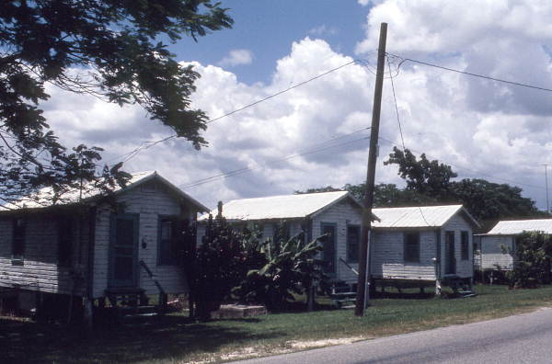

Row of shotgun houses

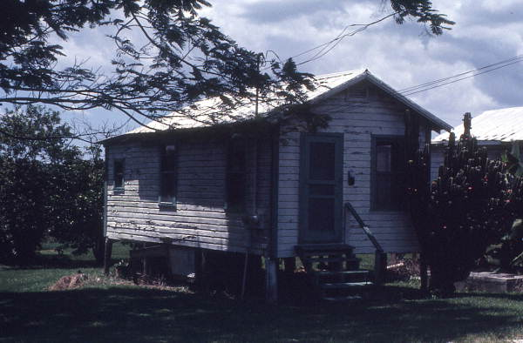
Close up of unidentified shotgun house in Pahokee, Palm Beach County, Florida
Credit this photo: State Archives of Florida, Florida Memory, https://floridamemory.com/items/show/108745
(please include photographer's name when noted).
See more at: https://www.floridamemory.com/items/show/108745#sthash.uaApnhWd.dpuf
https://www.floridamemory.com/items/show/108745

Pensacola, Florida
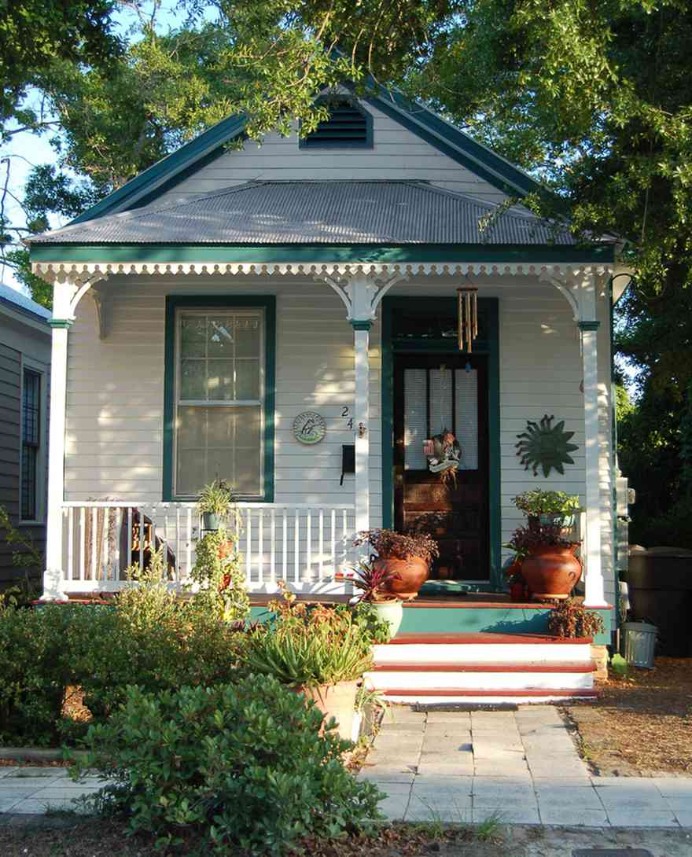

Seville Historic District: 249 East Intendencia Street

There are approximately a dozen of this style home remaining in the district. These houses were built for mill workers. There are three in a row in the 200 block of Intendencia St.

In the 1800’s many new buyers couldn’t afford Victorian, Edwardian, or Queen Anne homes that were popular at that time. To make purchasing more affordable, something simpler was needed. They looked for a structure that could be erected easily, quickly and inexpensively. The shotgun house filled the bill.

As the shotgun house evolved through the 19th century, it was embellished with decorative elements borrowed from popular tastes of the time, from Greek revival to Victorian gingerbread.

Film North Florida
http://filmnorthflorida.com/photos/location/Pensacola:-Seville-Historic-District:-249-East-Intendencia-Street

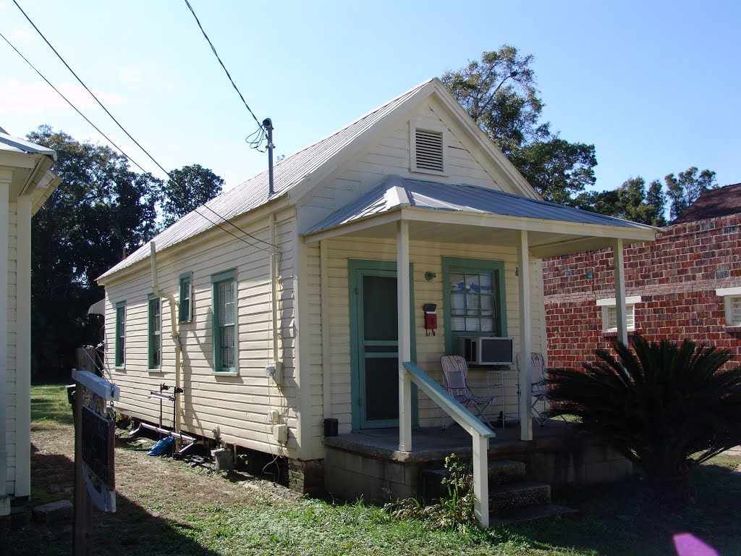
True SHOTGUN house, Seville Quarter, Pensacola (12-30-2011)
http://www.panoramio.com/photo/87092992

St. Augustine, Florida; Lincolnville Neighborhood
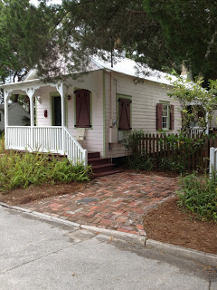
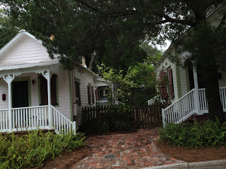
From: A Lincolnville Bike Tour, Wednesday, June 19, 2013

We take a small detour down Kings Ferry Way to see two nicely restored shotgun houses which together form a little compound with a courtyard between, an interesting way to expand a small property. These two shotgun style houses were restored by the Elaine H. Darnold, Inc. Construction Company which specializes in historic restoration. -

Lincolnville was the first St. Augustine neighborhood to be approved for designation as a National Register District, approved for designation in 1991. Lincolnville was founded shortly after the Civil War by emancipated African Americans from the area. It was originally called "Little Africa" but was later renamed in a reference to President Lincoln. It is composed of over 500 structures with the largest number of 19th and turn-of-the-20th century Victorian houses in the City. Today it has become one of the City's most interesting restored areas with many of the two-story Craftsman style and one-story Shotgun style houses lovingly restored.

See more at: http://fpangoingpublic.blogspot.com/2013/06/a-lincolnville-bike-tour.html#sthash.81XUL1Pw.dpuf

Sarasota, Florida; Overtown Community
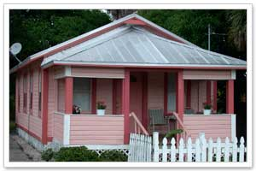
A concentration of 12 to 15 shotgun houses existed in historic Overtown, an African American community located immediately north of downtown Sarasota west of Lemon Avenue. The building pictured has many characteristics of a Shotgun House, although an un-altered one could not be located in Overtown.

Shotgun houses first became common in Florida after the Civil War, when newly freed slaves began to establish their own communities and neighborhoods. The style appeared throughout Florida in a variety of rural and urban settings.
Freestanding and one room wide, the Shotgun offers a front façade containing a doorway on one side and a window on another. Generally austere, many Shotgun Houses, nonetheless, feature decorative woodwork on doors and porches and under eaves. Windows are often oversized to allow the generous play of light and air. There are no interior hallways. Each room opens to the next to maximize living space and to keep construction costs low.
In Sarasota, shotgun style structures were associated with local turpentine camps which existed in scattered rural locations throughout the county.

From: Sarasota History Alive, September 8, 2008
Architect's Corner - Shotgun House 1866-1940
(Source: Sarasota County Design Guidelines For Historic Properties manual.)
http://archive.sarasotahistoryalive.com/this-week/this-week-newsletter-september-8-2008/

