Colorado

Ouray, Colorado 3

Ouray, Colorado
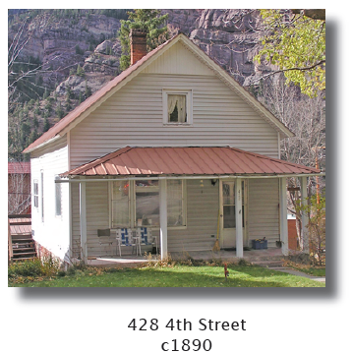
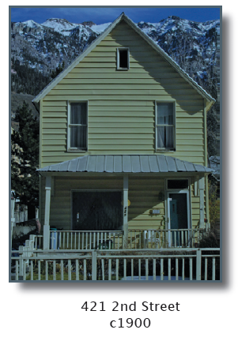

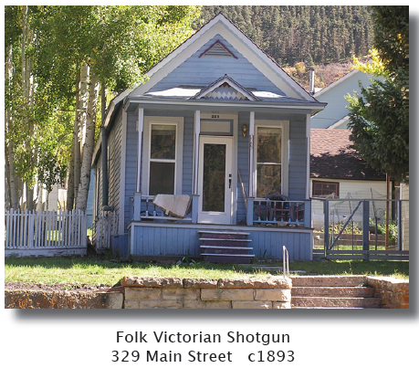
Ouray was a booming mining and distribution center within the San Juan Mountains from 1875 to the decline of mining in the early 20th century.

National Folk Houses : Simple houses without decorative trim served the needs of many early residents. One-, 1 1/2-, or sometimes 2-story simple front-gabled, side-gabled, gable-front and wing, pyramidal (hipped-roof box), and shotgun houses were constructed throughout the community.

Ouray’s Architectural Heritage
Ouray National Historic District
City of Ouray, Ouray County Historical Society, 2006

www.ouraycountyhistoricalsociety.org/3HistDistBookRev3.pdf

