California

Los Angeles, California; Hyans St., Filipinotown 3
Los Angeles, California; Watts Towers 4
Los Angeles, California, Watts House Project (WHP) 5
Santa Monica, California; Belmar Place (1953) 6

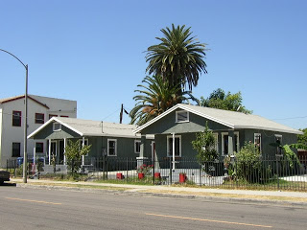
Los Angeles, California; Hyans St., Filipinotown

Along Hyans St, Benton Way and Council St, a few "shotgun" houses (pictured left) can be seen, and are hardly found anywhere else in Los Angeles. These narrow houses, designed without a shared interior hallway, are a familiar sight in the South, particularly in Louisiana. Their name derives from the fact that one can fire (in a straight line) a shotgun from the backyard to the front yard, provided all the doors of the house are open.

SG Houses in LA on Hyans St, Benton Way, & Council St; by Militant Angeleno 2/16/2010
Believe it or not, though the tiny Crescent City is vastly different than the ginormous City of Angels, there are a few things shared in common between them (yes, aside from Reggie Bush).
Both cities were founded by a river, have a "Mid-City" district, are important coastal port cities and are multicultural cities that have spawned fusion cuisines. Both cities have a huge Catholic influence. Interstate 10 runs through both The Big Easy and The Big Orange. And singer/songwriter Randy Newman has written songs about both cities - he grew up in both of them.
But here's something interesting the Militant discovered: Both Los Angeles and New Orleans have streets named "Rampart" and "Carondelet" that are not only parallel to each other but just a couple blocks apart, with both Ramparts located to the northwest of the Carondelets. Both pairs of streets in both cities run in a diagonal direction, from the southwest of the northeast. In New Orleans, the streets are located in the Downtown area; in Los Angeles, they are located in the Historic Filipinotown and Westlake districts.
Perhaps it was intentional -- in what is now Historic Filipinotown, just behind the former Rampart Police Station (which was on Benton Way and not Rampart Blvd), lies Hyans St, which was the first block in Los Angeles where African Americans were able to own their own property.
Being that most African Americans who settled in Los Angeles in the late 1800s-early 1900s came from places like Louisiana and Texas (and prior to World War II, they settled in places like Mid City and Jefferson Park), they probably not only brought the names of places familiar to them, but familiar architecture as well.
http://militantangeleno.blogspot.com/2010_02_01_archive.html

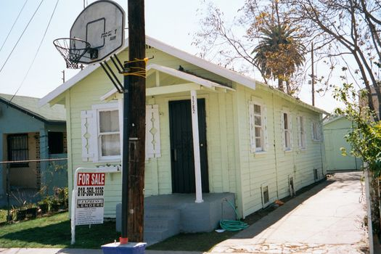
Los Angeles, California; Watts Towers
Shotgun House in Watts

Across the street from the Watts towers, a shotgun house of Rodia's vintage.

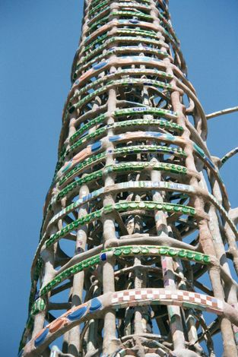
From Notes on the Geography of The Western United States: Los Angeles 3

Five miles south of downtown Los Angeles, rings of glass from old 7-Up bottles brighten one of the Watts Towers. The towers are made of steel rods caked with concrete in which glass, tile, pottery, and shells are embedded. They were built by Simon Rodia, an Italian immigrant who bought a lot in Watts in 1921. He called this project Nuestra Pueblo and worked on it until 1954, when he moved north to Martinez, near San Francisco. He lived there until 1965 and never returned to the towers, which on departing he had deeded to a neighbor. The city of Los Angeles tried to demolish them in 1957, but citizen action saved them, and in 1978 they were deeded to the state.

Los Angeles, California, Watts House Project (WHP)
Composed of a central green space and three freestanding shotgun houses, The Platform is a multi-use space, which, in addition to hosting community-run events, will also host an office, exhibition space, and artist-in-residency program. WHP partnered with the School of Architecture at USC to complete a major façade improvement on two of the houses and a full renovation of the facility.
Before
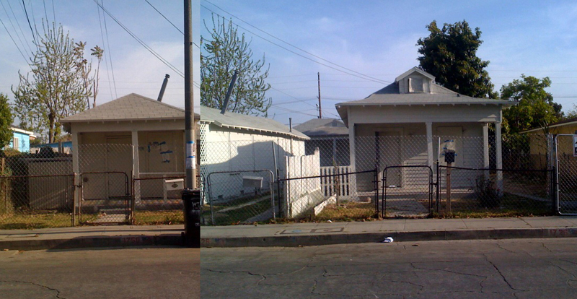
After
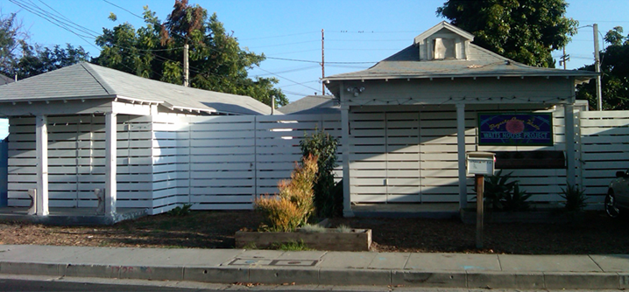

Santa Monica, California; Belmar Place (1953)
Burning a derelict house on Belmar Place between Main and Third Streets, north of Pico, on July 1, 1953.
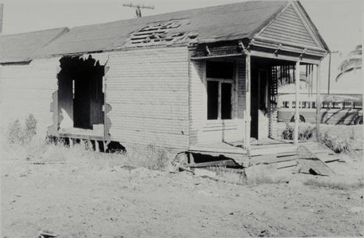
Slum clearance in preparation for the Civic Center project.
Before they set it on fire. Note the decorative corbels above the porch.

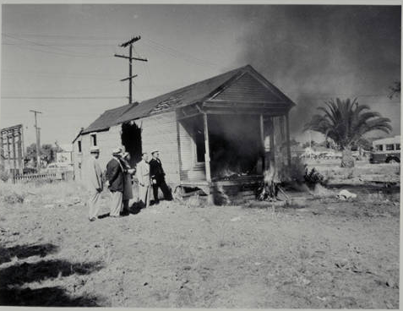

The picture shows what’s left of the Belmar Triangle neighborhood before the Civic was built.
Photographed by Clyde V. Fitzgerald, Sanitation Inspector for the City of Santa Monica.

Santa Monica Public Library Image Archives. (A840; Digital object 4831 img0082)

