Arkansas

Capitol Hill, Arkansas 3
Crossett, Arkansas; Crossett Company House Museum 4
Mountain Home, Arkansas 5
Pike County, Arkansas 7

Capitol Hill, Arkansas
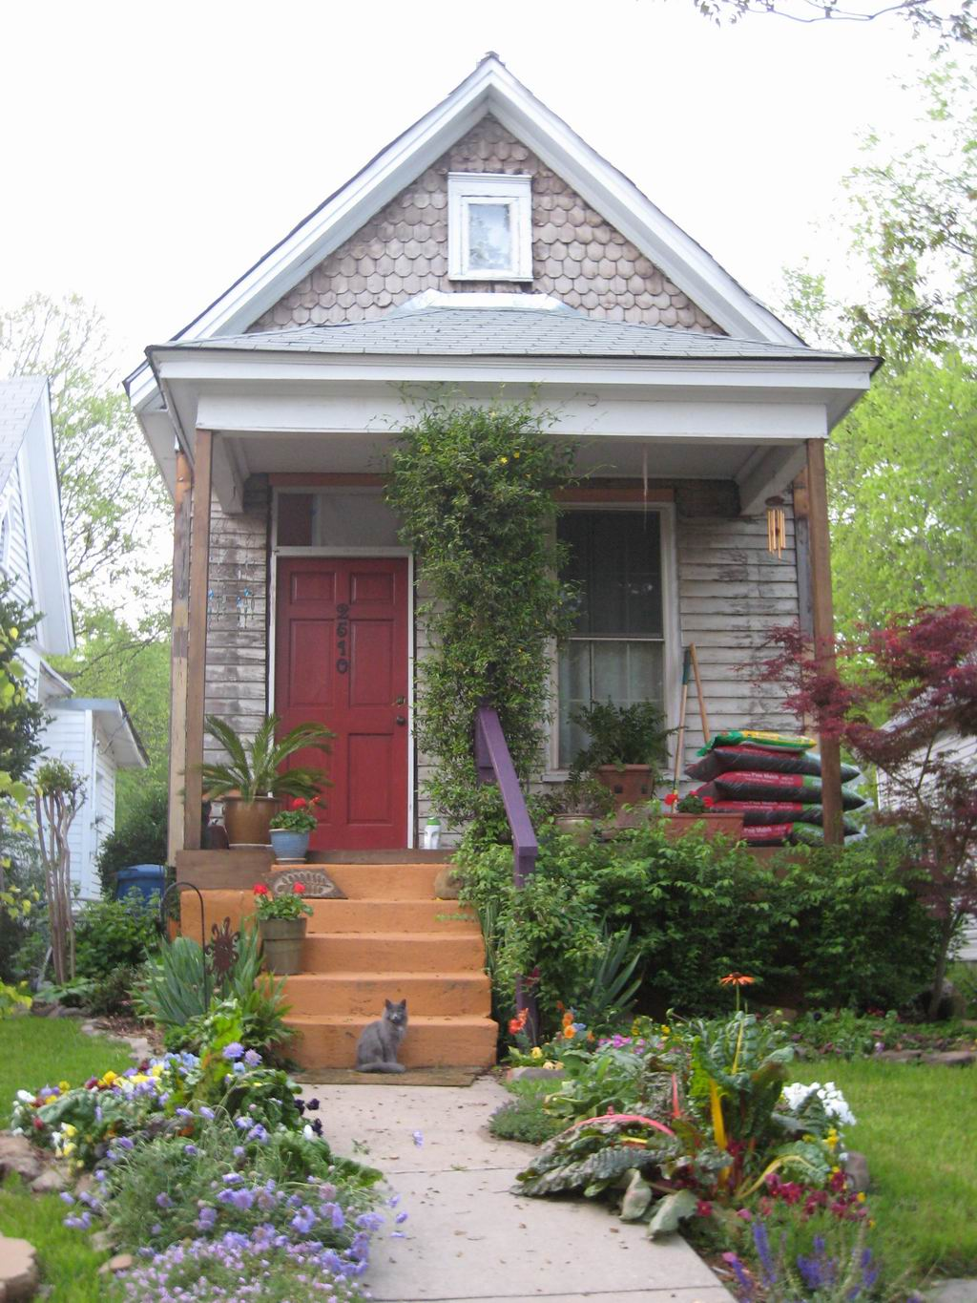
This shotgun house on West Sixth Street was likely built for a railroad employee
"Shotgun House in Little Rock Arkansas" by Bruce W. Stracener
https://commons.wikimedia.org/wiki/File:Shotgun_House_in_Little_Rock_Arkansas.jpg#/media/File:Shotgun_House_in_Little_Rock_Arkansas.jpg

Crossett, Arkansas; Crossett Company House Museum
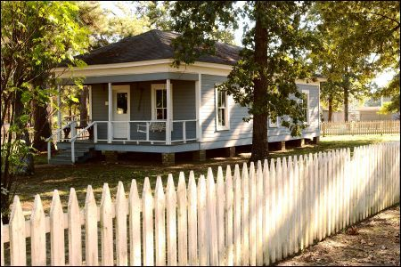
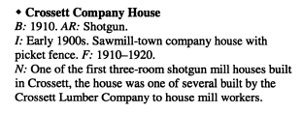

Mountain Home, Arkansas
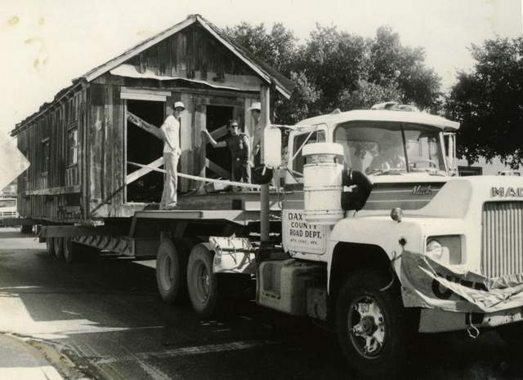

Shotgun House on moving day. / Courtesy of Baxter County & Genealogical Society
A Look Back: If this 'shotgun house' could talk...
Shotgun House - Preserving our history

Mar. 4, 2012
If this old “shotgun house” could talk, it would tell many interesting stories. It was destined to be torn down and forever lost when Dr. and Mrs. Douglas Marx decided to donate it to the Baxter County Historical & Genealogical Society.
At that time, the house was thought to be more than 100 years old. It is called a shotgun house because the doors in all three rooms of the house — living room, kitchen and bedroom — all were in line so that if you shot a gun through the front door it would go out the back door.
Plans were made to preserve the historic house for future generations to see. It was loaded on a lowboy trailer-truck and hauled through Mountain Home to be set beside the Casey House next to the Baxter County Fairgrounds, temporarily. When the Rapps Barren Settlement was being developed in Cooper Park by the BCHGS, the shotgun house was loaded up again and hauled to its permanent location there. It has been restored to its original condition as near as possible.
This house originally was located on a farm about two miles north of Mountain Home and about one mile west of AR Highway 201. Through much research, we know that the farm was owned by James and Ophelia Lowery Rogers in the 1930s and early 1940s. According to Leslie Walker, who lived near the farm all of his life (1918-2010), he remembered when the house was built. He said Chester Studdard was working on the farm for Rogers when Chester, better known as “Check” Studdard, married Doris Hickman. They needed a place to live and Rogers hired Check and his brother, Jewel Studdard, to build the small house. Walker said Check and Doris were the first people to live in this house immediately after they were married.
Willadean Hickman Perry, who also still lives here, verified that her cousin Doris and Check lived in the house when they were newlyweds. In a phone call with the Studdards’ daughter, Mary Lou McDaniel stated her parents were married Dec. 31, 1932. We have a newspaper article about their 50th wedding anniversary which also confirms the date. So, we must conclude that the house was built in late 1932 or early 1933. Might we venture a guess that used lumber was obtained as was common in those days to economize when possible. Gene Garr and others who helped restore the old house were adamant about its age being over 100 years.
In the house’s early years, Roy and Annie Pyeatt made this shotgun house their home. According to Sterlene Bryant Burris (deceased), she was living in this house at age 7 with her parents when her brother returned home from World War II in the mid 1940s. Another well-known family who called it home was Ed and Kathy Roberts Crawford. Their daughter, Laquita Crawford Foster, remembers their family, including a grandmother, living in the small house when she was a child. Laquita now works at Arkansas State University Mountain Home. The Isaac Watts family lived there in March 1935 when their third son, Bill, was born. He still lives in Mountain Home, but doesn’t know how long his family lived there. If you have information of other people who lived in the shotgun house, we would love to have their names and approximate dates.
Joan Reeves had the privilege of showing two of Ophelia Rogers’ granddaughters the little house that belonged to their grandmother so many years ago. The Shotgun House now rests proudly with the Talburt-Leonard Cabin, the George Washington Jones Cabin, and the Shady Grove School at the Rapps Barren Settlement in Cooper Park for all to see and be reminded of times past.
Photographs and information provided in this series was provided by the Baxter County Historical and Genealogical Society. Additional information may be found at www.baxtercountyhistory.org.
http://archive.baxterbulletin.com/article/20120305/NEWS01/303050004/A-Look-Back-shotgun-house-could-talk- http://baxterbulletin.newspapers.com/search/#query=shotgun+house

Pike County, Arkansas
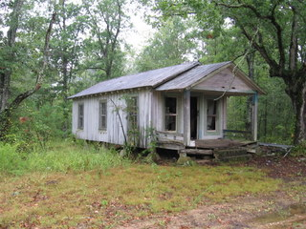
This small shot-gun house is all that remains of a small farming community now in the boonies of east Pike County, Arkansas. Since this photo was taken the house has been restored and is now serving as a deer camp.
Read more: http://www.city-data.com/forum/attachments/arkansas/58193d1266369828-exploring-arkansas-shotgun-house.jpg
http://www.city-data.com/forum/arkansas/878079-exploring-arkansas-little-rock-amity-delight-2.html#ixzz3muXfktWH

