Alabama

Birmingham, Alabama 3
Greensboro, Alabama; The Safe House Black History Museum 4
Lake Martin, Alabama 5
Mobile, Alabama 6
Montgomery, Alabama 9

Birmingham, Alabama
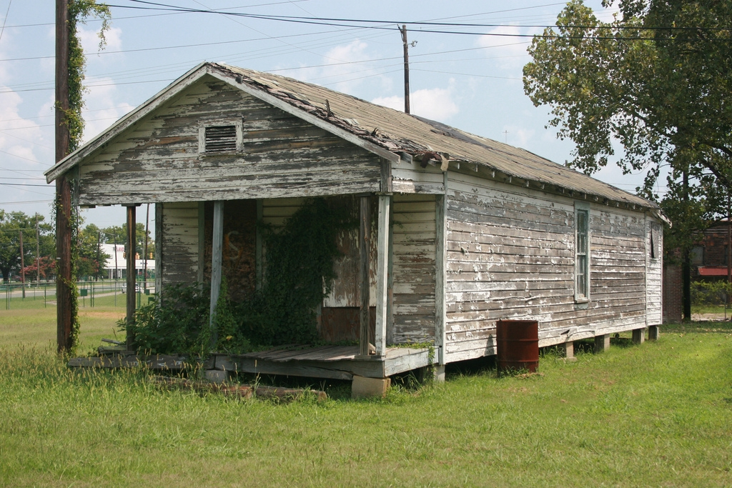
Shotgun House
Many of the men who worked at the Sloss Furnaces lived nearby in company-owned housing called the Sloss Quarters. Designed specifically for black workers, the houses were typical shotgun-style structures, with two or three rooms set on foundation posts and no indoor plumbing. The Quarters were demolished in the mid-1950s

From: Sloss Furnaces National Historic Landmark
http://www.hmdb.org/Marker.asp?Marker=43973

Greensboro, Alabama; The Safe House Black History Museum
The Safe House Black History Museum at Greensboro, AL was recently renovated by Auburn Rural Studio
Auburn Rural Studio, Black Heritage, Museums & Rural Art | Greensboro in Hale County
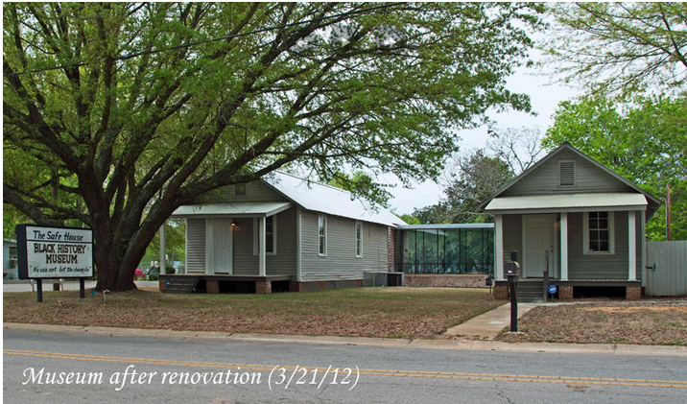
On the night of March 21, 1968, Rev. Martin Luther King Jr. sought refuge from the Ku Klux Klan inside a small, shotgun-style home in the depot neighborhood of Greensboro, AL. (This occurred just two weeks prior to the assassination of Rev. King in Memphis, TN.) Mrs. Theresa Burroughs, a close friend of the King family and an active participant of the Civil Rights Movement, turned this small shotgun house into the Safe House Black History Museum which documents the local struggle for equality. It contains relics of the period from slavery through the civil rights movement. Displayed at the museum are many unpublished photos of the civil rights struggle in the Black Belt. These include photos of the Greensboro marches, of Bloody Sunday in Selma, and of the triumphant march from Selma to Montgomery.
http://www.ruralswalabama.org/attraction/the-safe-house-black-history-museum-at-greensboro-al-recently-renovated-by-auburn-rural-studio/

Lake Martin, Alabama
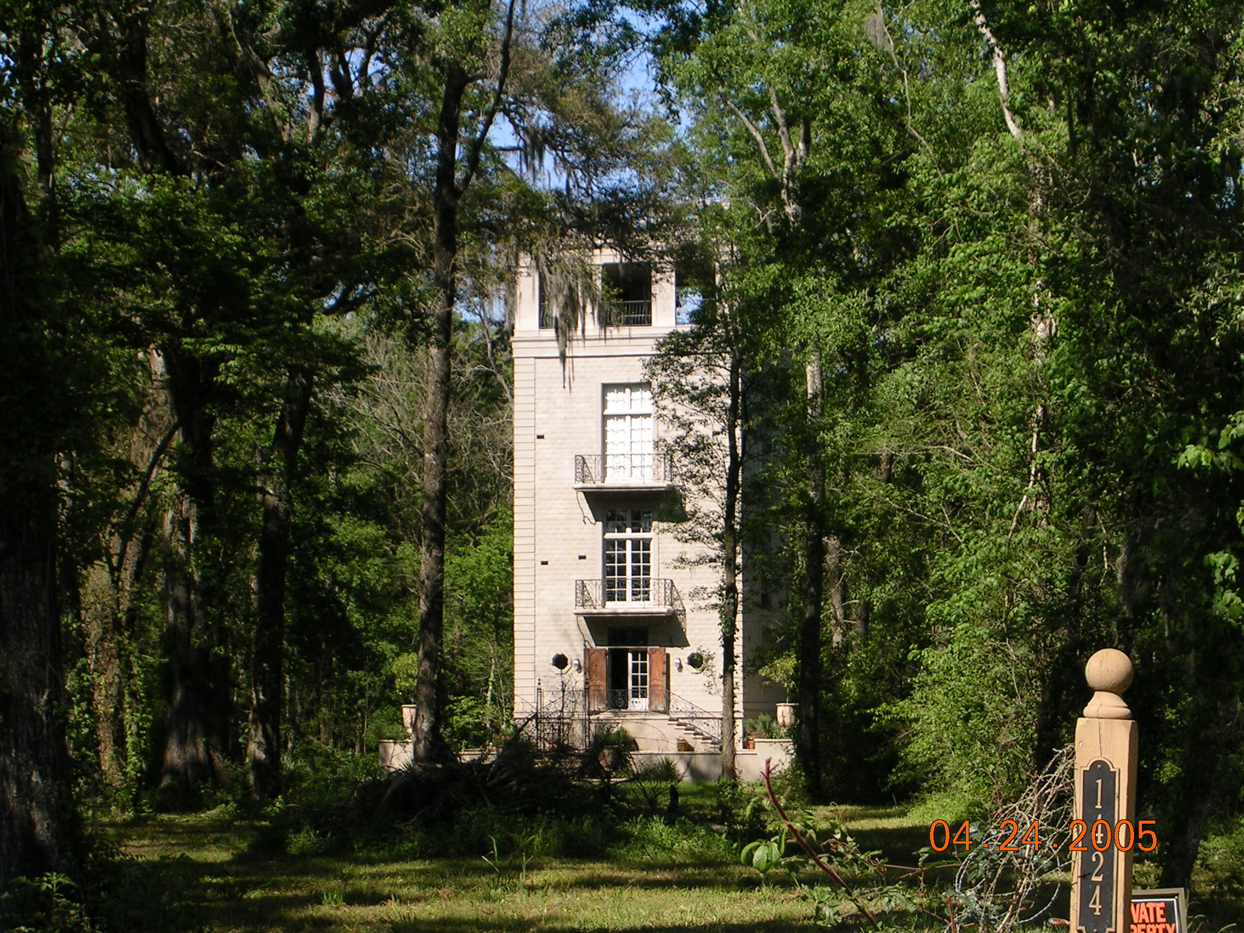
Vertical shotgun house at Lake Martin
https://www.pinterest.com/pin/117726977735569216/

Mobile, Alabama

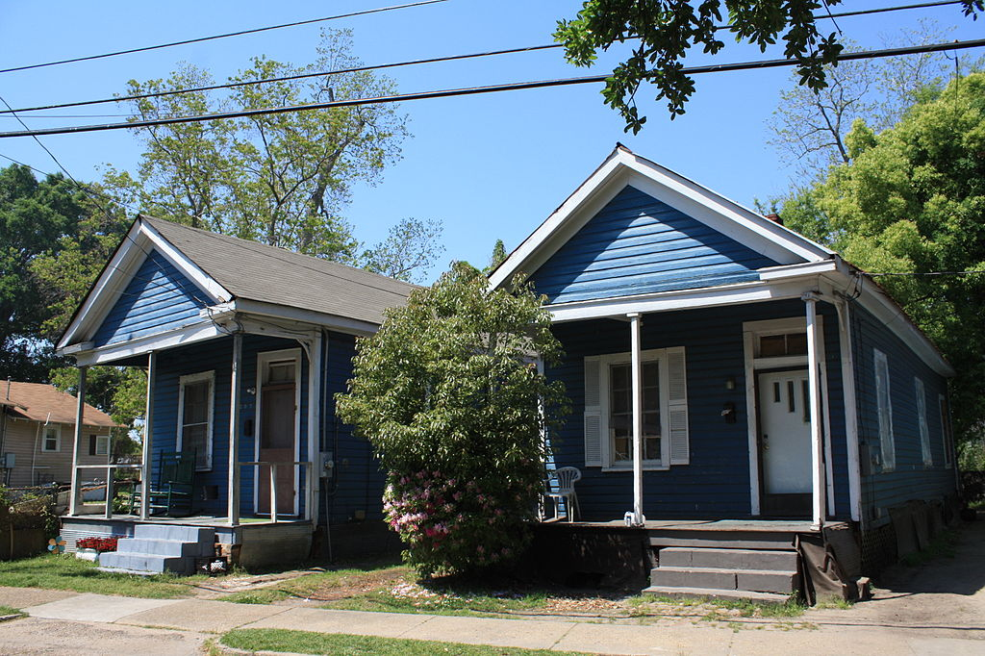
The Shotgun house is an example of an American vernacular style: A pair of single shotgun houses, dating to the 1920s, in the Campground Historic District of Mobile, Alabama
"Campground Historic District" by Jeffrey Reed. Licensed under CC BY-SA 3.0 via Commons - https://commons.wikimedia.org/wiki/File:Campground_Historic_District.JPG#/media/File:Campground_Historic_District.JPG

Saving a little piece of history, a Savannah Street Shotgun
My husband and I love Mobile's historic architecture. After several fires early this year in the Oakleigh Garden District, we decided it was time to do our part and try to save one of the old houses. We purchased the Verneuille Cottage built in 1888. Although slightly damaged by one of the fires, it was not nearly as bad as it looked. We managed to save a good bit of the original fabric of the house and only replaced the old parts with new where absolutely necessary. The work has gone a good bit faster than we ever imagined thanks to an excellent contractor.
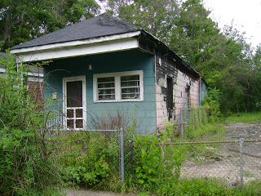
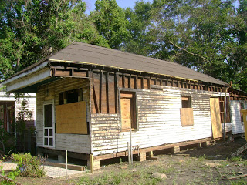
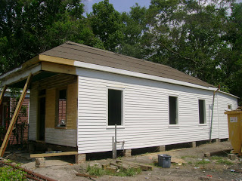
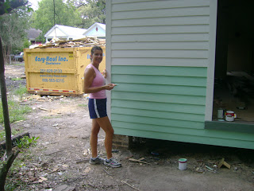

Project complete...
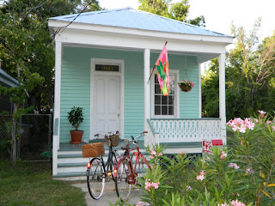
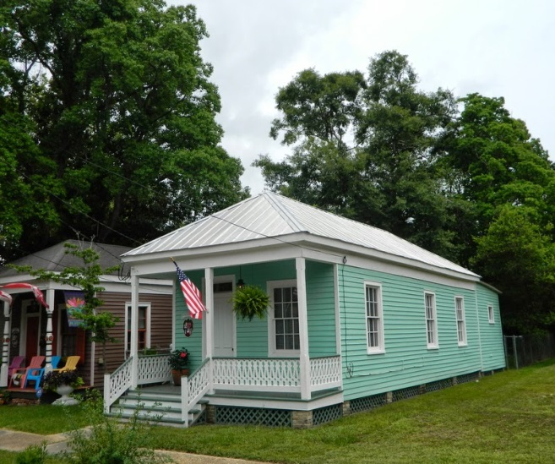
About me, Simona,
I was born in Rome, Italy and spent the first 28 years of my life in Rome. As a child, Mobile and the Gulf Coast was a vacation place for my family. Images of white sand beaches and plantation homes filled my imagination. In 1997 I decided to make a permanent move to Mobile, Alabama following in the foot steps of my great-aunt who married an American Soldier and native Mobilian during World War II. I, along with my husband, David, and daughter, Eleonora, live in Mobile's Historic District.

http://mylifeinmobile.blogspot.com/2011/07/saving-little-piece-of-history-savannah.html

Montgomery, Alabama
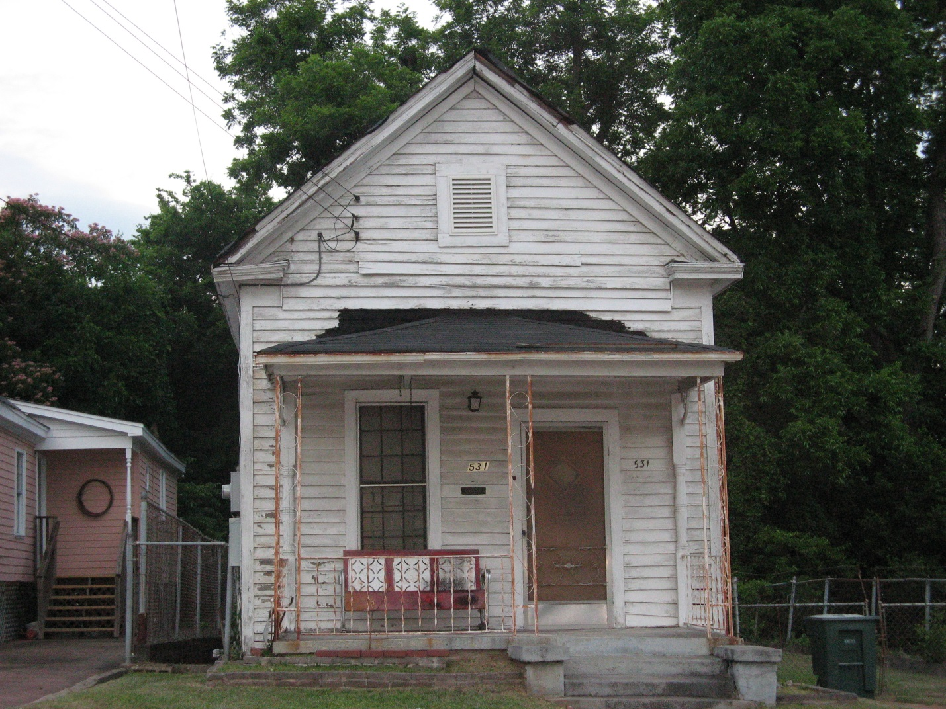
A more traditional shotgun with a steeply pitched gable roof, this example draws design strength from strong geometry.

The shotgun house, our peculiar southern, indigenous urban cottage came next. It was popular from after the Civil War until about 1920. These narrow, long houses were called shotguns, so the story goes, because you could fire a shotgun through the front door and the blast would go out the back door without striking a thing. My limited experience with guns tells me this could be better accomplished with a rifle, so you can take the story of the name with a grain of salt. Their true origins are murky, but probably represented a cheap, land-conserving way to house a large number of people in a small space while still recognizing our Southern preference for having our own home.
From Midtown Montgomery Living, The Small House, admin 30 May, 2013
Architecture, Elizabeth Ann Brown, Historic Midtown
http://www.midtownmontgomeryliving.com/?p=37440

